THERMAL PLASMA TREATMENT OF SOLID WASTE

Tan Hiang Mong^{*)}, Tan Tiam Kwei^{*)}, Leow Poh Chin^{*)}, Calvin Tan^{*)},
G.Paskalov^{**)}, I. Gafarov^{**)}
^{*)}AEL Enviro (Asia) Pte Ltd, Singapore, 120 Pioneer Road #01-03 Singapore 639597,
^{**)}Scientific-Development Company “RENARISORB Ltd.”, 88, Bldg. 3, Aht. 100, Leninskiy prospect, Moscow, Russia
e-mail: hmtan@aelenviro.com , renari_sorb@mail.ru

This paper describes a system for solid waste processing using Radio Frequency (RF) plasma and thermal heating. Solid waste includes different raw materials, including used tires. Process parameters varies considerably and are dependent of the process temperature and energy used. Therefore, when designing a system and installation, the following requirements are important:

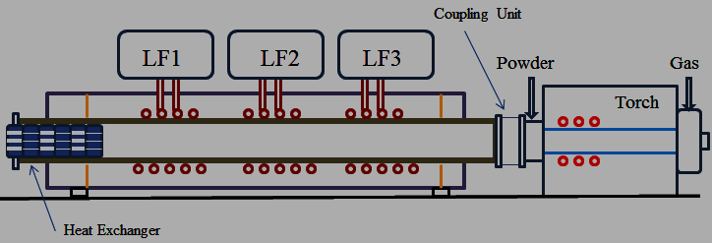
a
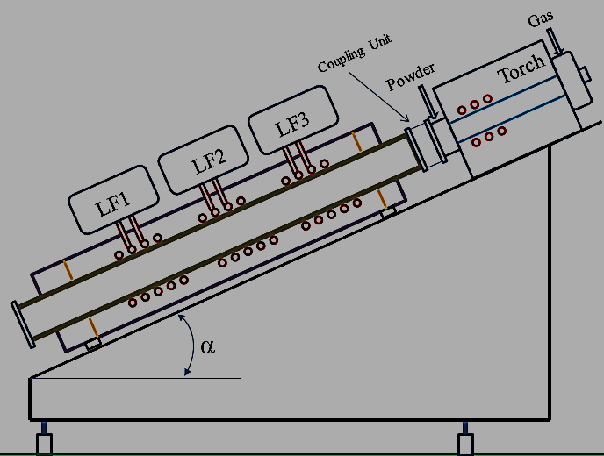
b
Fig. 1 Configuration of the system:
a – horizontal configuration; b – angled configuration

The possibility of various physico-chemical processes and their combination;

- Interchangeable modules (even multi-purpose modules), providing unification of joining and contiguity;
- Functional completeness of modules that allows conducted combined stage process;
- Maintainability modules arising from the requirements of interchangeability, and opportunities for effective maintenance;
- Complete design, which could provide high technological parameters of functioning.

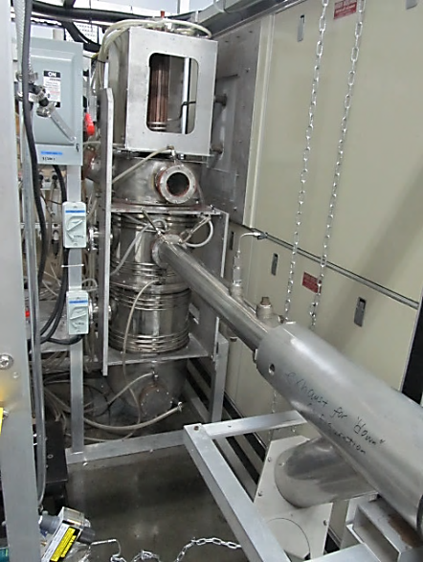 |  | 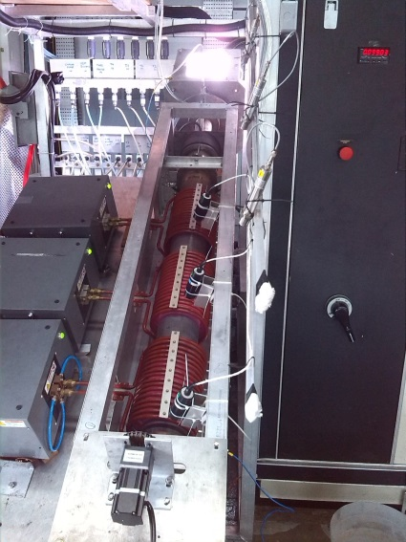
Fig. 2 General view of equipment with different configuration
This allows us to create custom design devices and developed maximum-specific chemical processes.

The module is equipped with High-frequency Induction Plasma Torch, RF Generator (2 MHz Frequency at power level of 100 kW). Additional to the plasma part, the reactor contents low-frequency (LF) induction heater. LF frequency heating generators are in 20 - 40 kHz frequency range at 15 kW power level (Figure 1). Modular construction of the installation allows different connection combinations of process equipment and the establishment of technological regimes depending on tasks. For example, the process system could use RF plasma torch or LF induction heater only or combined treatment (HF + LF) (Figure 2). This principle provides the flexibility of the equipment by transforming internal and external structure of a plant depending on its purpose. Temperature processes can be adjusted from 500 °C to 5000 °C. Studies of the energy characteristics of the module shows that in the reaction zone, power from 1 kW to 75 kW can be achieved.

This system is used to study the process of recycling waste tires. Defined regimes where typical products are distinguished during the tire recycling process, such as: Synthesis Gas, Liquid Fraction and Carbon. In some experiments we observed only Synthesis Gas and Carbon Black (without Liquid Fraction). Analyses showed that in this regiments the calorific value of synthesis gas is much higher. Also, the fraction of nano-sized carbon black increased. Some experimental results are shown in Figure 3.

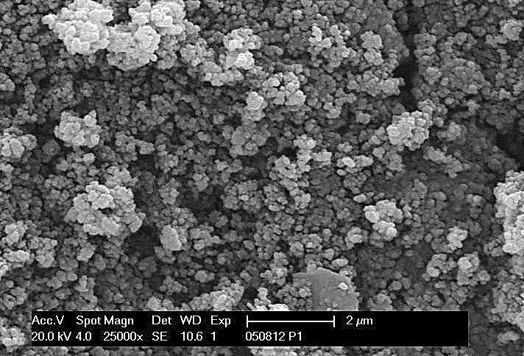
FIG. 3 Experimental results and carbon black SEM

This study shows that the advantage of the described system over other conventional methods used in the market is one possibility of adapting the equipment to variable loads and different Physical and Chemical properties of recycled materials.

