THE STABILIZATION OF SCLERA BY GLYCATION
N.A. Danilov, N.Yu. Ignatieva
The Chemistry Department of Moscow State University, Russia, 119991, Moscow
danilovchem@mail.ru, nyu@genebee.msu.ru

Abstract. The work aims at the evaluation of prospects for using glyceraldehyde and threose as a cross-linking agent for stop myopic progression. Stability parameters (denaturation temperature, Young’s modulus, proteolytic resistance) and fluorescence intensity were monitored as function of glycation time for isolated rabbit sclera. It is shown that such treatment result to considerably increase in all stability parametres. Unique shown features at small times of reaction of collagen with glyceraldehyde or threose are explained. The scheme of Gibbs free energy changes of collagen in scleral tissue was constructed for various conditions.

Introduction. In progressive myopia, collagen fibers of the sclera develop pathological changes related to a decrease in the number of intra- and intermolecular cross-links, which causes deterioration of the biomechanical properties of this supportive eye shell [1, 2, 3]. Methods of sclera strengthening in progressive myopia that increase biomechanical stability by action of cross-linking agents are expected to be very promising. However, new methods can only be introduced into clinical practice after thorough in vitro and in vivo research. Such interdisciplinary research must start with studying physical and chemical changes of collagen structures occurring in the tissue after it has been treated with cross-linking agents.
Glyceraldehyde and threose monosaccharides are seem to be a promising cross-linking agent as they are small-toxic, has high cross-linking activity and the reaction duration degree can be easily measured by non-invasive method - tissue autofluorescence in near ultraviolet light.
The purpose of this work is to determine kinetic dependencies of important parameters, such as collagen denaturation temperature (Td), enzymatic stability, Young’s modulus (E) and fluorescence intensity, in the process of stabilization of scleral collagen during glyceraldehyde or threose cross-linking. It is to be noted that Td is the most important thermodynamic characteristic of tissue stability [4], and fluorescence is an analytical parameter that reflects the depth of glycation process [5]. It should be noted that proteolytic resistance is a very important parameter, because it will determine a time length of curative effect. Collagen in a living organism is subjected to gradually degradation with matrix metalloproteases and resynthesis (turnover) [6].
Materials and methods.
Tissue preparation. The specimens of sclera were obtained from 20 eyes of 9-month rabbits which were sacrificed within the framework of other ethically approved experimental research. For biomechanical measurements, 12x4 mm strips were dissected from the slices of sclera. The trimmings were divided into many small pieces of about 1–12 mg dry weight. The pieces were randomly mixed and subsequently used to carrying out all other experiments (DSC, fluorescence and digestion measurements).
Cross-linking (glycation). The samples were incubated at 37 °C in 1.5 ml 0.1 M phosphate-saline buffer solution from 1 to 40 hours with 0.1 M D,L-glyceraldehyde (GA; Sigma) or from 0.5 till 7 days with less active 0.1 M threose (TR; Sigma). Then, the cross-linked samples were shaken thoroughly in a warm (~30 °C) 0.1 M Tris–HCl buffer (THB) to remove and inactivate adsorbed reactive carbonyl compounds [4]. Uncross-linked samples incubated in the same buffer solution without GA or TR are referred to as “intact” and used as a control for all studies.
Differential scanning calorimetry (DSC). The specimens of about 3–8 mg in dry weight equivalent were immediately encapsulated in an aluminum hermetic seal pan after withdrawal from the incubation solution. Empty pan was used as a reference. The DSC instrument was a computer-controlled TA400 (Mettler, Switzerland). Start temperature, end temperature and heating rate of the DSC measurements were 25°, 100˚C, 10º/min. The denaturation temperature (TD) was defined as the temperature of the peak transition (Tm).

Biomechanical tests. The biomechanical analysis of scleral samples was carried out using the MINIMAT-2000 Materials Testing Device (Rheometric Scientific GmbH, Germany). The tensometric sensor was set to 20 N. The sclera biomechanical properties were measured in tension by placing the specimen between the clamps and pulled to rupture at a crosshead speed of 1 mm/min. The data were digitized, displayed and recorded using an IBM computer. From the stress-strain dependency curve Young’s modulus was calculated for each specimen (E, MPa).

Enzymatic digestion. The proteolytic preparation “Moricrase” obtained from the hepatopancreas of king crab Paralithodes camtschatica was used for collagen digestion [7, 8, 9]. In a typical experiment, approximately 10 mg samples of (non)-cross-linked scleral collagen were immersed in 1.5 ml of a 0.1 M Tris-HCl buffer containing 25 mM CaCl₂, 0.02% (w/v) NaN₃ and 0.2% (w/v) of aforementioned preparation. The incubation was performed for 72 h at 37°C. A gravimetric method was used to determine the weight loss of the samples. The digestate was decanted and the remaining pellet was washed with deionized water (MilliQ), lyophilizated and weighted. The changes in weight of partially degraded samples were expressed as the percentage of the initial weight (WR, weight remaining, %).

Fluorometry. The samples of about 1–5 mg dry weight was digested by 0.5% papain (Sigma, 2.9U/mg) in 1.5 ml 0.1 M Tris-HCl buffer. Then, 200 μl of papain digest was taken and added to 1800 μl of the same buffer. Resulting solution was put into the quartz cuvette (l=1 cm) of the spectrofluorophotometer SM2203 (Solar, Byelorussia). Fluorescence intensity (FI) was defined as intensity in the maximum of the spectral curve at excitation wavelength of 370 nm according to literature data [5]. All of obtained values of FI were normalized to the collagen content of the digest, i.e. fluorescence intensity per milligram collagen (NFI, normalized fluorescence intensity, expressed as “RFU” – relative fluorescent unit). The collagen content of the digest was determined by the hydroxyproline assay (see below).

Collagen determination. Collagen present in the papain-digest supernatants was estimated by measuring the amount of collagen-specific amino acid hydroxyproline [10]. An aliquot of the supernatant was hydrolysed in 1 ml of 6.0 N HCl at 110°C for 16 h in an autoclave. The HCl was removed in vacuo and the amount of hydroxyproline was determined by a modification of the method of Woessner [11]. Hydroxyproline was assumed to comprise 13.5% of the collagen by weight [12].
Results and discussion. As shown in Fig. 1, a rapid initial rise (from 0 to 10h in case of GA and 0-3 days in case of TR) on all observable parameters was followed by a transition to a relatively constant plateau value approximately 12-18h for GA and 5-7 days for TR after the initiation fixation. This indicated that the fixation of scleral tissues by glyceraldehyde or threose was completed for these time intervals. In the cross-linked specimens, the Young’s modulus was gradually increased up to 400-600%. The very increase in Td, Youngs modulus and proteolytic stability unequivocally points out to increase of structural stability of scleral collagen owing to cross-linking process and perspectivity of the further studying of possibility of use of these reagents.
The unique features were observed on the early stages of glycation (t<3 h for GA and t < 2 days for TR): multi-peak transition on the DSC-thermograms with a significant percent of low-temperature fraction (Td<Td (intact)) for both GA and TR glycated samples and local minimum of proteolytic resistance in case of GA glycated samples (Fig. 2). Before the cross-linking process and on terminal stages of cross-linking, a single endotherm has been observed; however, between these stages, multiple denaturational transitions sometimes were recorded (fraction-1 has low temperature [61-64°] relative Td of Intact Samples, fraction-2 has Td=Td(intact samples) [67-68°], fraction-3 has a high temperature [71-80°] relative Td of Intact samples).

Several peaks on the DSC-thermograms indicate unambiguously the formation of several fractions of collagen possessing different properties, i.e., different fractions have different levels of cross-links (their heterogeneous distribution) or different types of cross-links, or different ways of triple-helix packing [13]. Further change of peaks points to transformation of these fractions in the course of cross-linking.

A similar effect was observed for glutaraldehyde cross-linked dermal sheep collagen and it is connected to diffusion effects of glutaraldehyde penetration through already cross-linked surface layers of collagen fibrils and with possible distribution of aminogroups activity in different sites of the same sample [14].
The collagen fraction with increased Td is result of cross-linking process. Those sites of the sample or collagen fibrills in which reaction has not yet passed sufficiently, have Td = Td (intact sample) (fraction-2 on Fig. 2).

The detection of low-temperature peaks on DSC-thermograms of early glycation samples is a very interesting result. It was observed by some investigators for collagen treated by acylating agents or monofunctional epoxy compounds [15, 16, 17]. Such treatment results in (masking or) branching of aminogroups, i.e., the fixative reacts with a single aminogroup, resulting in a side branch coming from the reacted aminogroup without forming a cross-link. This replaces the space adjacent to the relevant amino acid site, and the neighboring collagen is pushed away. It is resulted to local destabilization-distortion (loss of integrity) of the triple-helix conformation of the collagen molecules or a more random molecular packing in fibrils.

We believe that DSC technique detects collagen fractions that contain products of initial reaction glyceraldehyde or threose molecule with a single aminogroup of (hydroxy)-lysine or arginine. Such initial products – ketoamines, are really single side-chain; probably, forming crosslinks between neighboring aminogroups occurs later.
Such assumption about structural changes proves to be true presence of a local minimum of proteolytic stability in case of GA cross-linking. We observed considerable decrease in stability to "Moricrase" digestion in the range of 1-3 h, after its some increase in the range of 0-1 h. Similar dependence explains well by the inconsistent influence of "masking" effect on stability to enzymes: shielding of aminogroups may results in an increase of the proteolytic resistance because the cleavage sites become less accessible (without any cross-links), but on the other hand, masking can destabilize the collagen structure, as referred to above [15, 17].

Fractions with low Td and local minimum of proteolytic resistance gradually disappear; it seems to be in agreement with that the initial reaction products (“side-branches”) are turned into normal cross-links during glycation process.
It is considered that collagen denaturation may be described within the limits of model of first-order phase transition [18,19]. Collagen in fibrills forms the quasicrystal structure shown on X-rays images and electronic microphotos [20]. After denaturation these properties disappear, the amorphous phase is formed [21]. At cooling, these properties are partially restored. P.G. Flory has proved equality of chemical potentials only in one point by methods of statistical thermodynamics[21].
Therefore, the temperature denaturation may be calculated from enthalpy and entropy of transition, namely, Td = ΔH/ΔS.
We did not observe any changes of enthalpy during our experiments, and therefore we believe that change in value of Td is entirely caused by entropy change. Let's consider observed effects from the point of view of change Gibbs free energy (Fig. 3).
In the denaturation process, transition of a collagen macromolecule from a “triple-helix” state into a “random coil” state is occured. At temperature of tissue normal functioning (~300 K) the triple-helix structure is steady, its Gibbs free energy G (triple-helix) less than G (a random coil). Entropy S (a random coil) is essential more S (a triple-helix), therefore G (a random coil) falls faster with temperature growth, and on reaching temperature denaturation point there comes balance between these two phases (ΔG=0). The effect of masking aminogroups considerably increases entropy of a random coil because of appearance of new conformations, rotations aliphatic groups of a new side-chain round unary N-C and C-C bounds. Change of Gibbs free energy becomes equal to zero at lower values of temperature. In physical chemistry of polymers decrease in phase transition temperature at introduction in linear polymer of side-chains is well-known effect [22]. At last, in the cross-linked collagen network entropy of a random coil will be much less, than in no-crosslinked fraction, due to the reduction of number possible admissible conformations. Therefore, Td becomes much more in comparison with intact collagen.
Conclusions.
The treatment of isolated rabbit scleral tissue by 0.1М solution of glyceraldehyde or threose leads to substantial increase in structural and biomechanical stability due to the cross-links formation. The observable effect essentially depends on treatment duration: in 3 hours of processing of GA and 2 days of processing ТР increase in level of scleral cross-linking density gets steady character. The received results indicate to perspectivity of the further studying in vivo the given cross-linking agents as perspective means for scleral strengthening at progressive myopia. Threose can have advantage in vivo because of its smaller activity: more uniform distribution of cross-linking areas in treated tissue and smaller toxicity.
Interpretation of effects observed on DSC thermograms from the point of view of physical chemistry has been made. Set of the used physical and chemical methods allows to estimate a collagen state in tissues. It is important for the decision of actual problems of modern medicine.

Литература

1. Wollensak, G. Cross-linking of scleral collagen in the rabbit using riboflavin and UVA / G. Wollensak, E.N. Iomdina, D-D. Dittert // Acta Ophthalmol. Scand. – 2005. – V. 83. - P. 477-482.
2. Иомдина Е.Н. Биомеханика склеральной оболочки глаза при миопии: диагностика нарушений и их экспериментальная коррекция: aвтореф. дис. докт. биол. наук. / Иомдина Елена Наумовна. - М., 2000. - 48 с.
3. Wollensak G., Spoerl E. Collagen cross-linking in the human and porcine sclera / G. Wollensak, E. Spoerl // J. Cataract. Refract. Surg. – 2004. – V. 30. - №3. - P. 689-695.
4. Andreassen T.T. Thermal stability of collagen in relation to non-enzymatic glycolysation and browning in vitro / T.T. Andreassen, H. Oxlund // Diabetologia. – 1985. – V. 28. - P.687-691.
5. Malik S.N. Ageing of the human corneal stroma: structural and biochemical changes / S.N. Malik, S.J. Moss, A.J. Furth, K.M. Meek // Biochem. Biophys. Acta. – 1992. – V. 1138. - P.222-228.
6. Bailey A. J. Molecular mechanisms of ageing in connective tissues / A.J. Bailey // Mech. Ag. Dev. – 2001. – V. 122. - P. 735–755.
7. Руденская Г.Н. Аминопептидаза PC из печени камчатского краба: субстратная специфичность и исследования ингибирования / Г.Н. Руденская, А.М. Шмойлов, Д.В. Беседин // Вестн. Моск. ун-та. – 2000. - Т. 41. - №6. - Приложение. - С.70-72.
8. Rudenskaya G. Preparation of proteolytic enzymes from kamchatka crab Paralithodes camchatica hepatopancreas and their application / G. Rudenskaya, V. Isaev, A. Shmoylov, M. Karabasova // Appl. Biochem. Biotechnol. – 2000. - V.88. - P.175-183.
9. Semenova S. cDNA cloning, purification and properties of Paralithodes camtschatica metalloprotease / S. Semenova, G. Rudenskaya, D. Rebrikov, V. Isaev // Prot. Pept. Lett. – 2006. - V.13. - №6. - P.571-575.
10. Степанов, В.М. Молекулярная биология / В.М. Степанов. - М.: Высш. шк., 1996. - 337 с.
11. Игнатьева Н.Ю. Определение гидроксипролина в тканях и оценка содержания в них коллагена / Н.Ю. Игнатьева, Н.А. Данилов, С.В. Аверкиев, М.В. Обрезкова, В.В. Лунин, Э.Н. Соболь // Журнал Аналитической химии. – 2007. - Т. 62. - №1. - С. 51-57.
12. Gasteiger E. ExPASy: The proteomics server for in-depth protein knowledge and analysis / E. Gasteiger, A. Gattiker, C. Hoogland, I. Ivanyi, R.D. Appel, A. Bairoch // Nucleic Acids Res. – 2003. – V. 31. - P. 3784–3788.
13. Wallace D.G. Multiple denaturational transitions in fibrillar collagen / D.G. Wallace, R.A. Condell, J.W. Donovan, A. Paivinen, W.M. Rhee, S.B. Wade // Biopolymers. - 1986. - V. 25. - P. 1875-1893.
14. Cheung D.T. Mechanism of cross-linking of proteins by glutaraldehyde. III.Reaction with collagen in tissues / D.T. Cheung, E.C. Ko, M.E. Nimni // Connect. Tissue Res. – 1985. – V. 13. - P.109-115.
15. Zeeman R. Successive epoxy and carbodiimide cross-linking of dermal sheep collagen / R. Zeeman, P.J. Dijkstra, J. Feijen // Biomaterials. – 1999. – V. 20. - P.921-931.
16. Tu R. Fixation of bioprosthetic tissues with monofunctional and multifunctional polyepoxy compounds / R. Tu, S.H. Shen, D. Lin // J. Biomed. Mater. Res. - 1994. - V.28. - P. 677-684.
17. Sung H.W. Degradation potential of biological tissues fixed with various fixatives: An in vitro study / H.W. Sung, C.S. Hsu, S.P. Wang // J. Biomed. Mater. Res. - 1997. - V. 34. - P. 147-155.
18. Flory P.J. Phase transitions in collagen and gelatin systems / P.J. Flory, P.R. Garrett //JACS. - 1958. - V. 80. - P. 4836-4845.
19. Манделькерн, Л. Кристаллизация полимеров / Л. Манделькерн. - Л.: Химия, 1966. – 337 с.
20. Holmes D.F. STEM/TEM studies of collagen fibrill assembly / D.F. Holmes, H.K. Graham, J.A. Trotter, K.E. Kadler // Micron. - 2001. - V. 32. - P. 273-285.
21. Engel J. Cooperative equilibrium transitions coupled with a slow annealing step explain the sharpness and hysteresis of collagen folding / J. Engel, H.P. Bachinger // Matrix Biol. – 2000. – V. 19. - P. 235-244.
22. Flory, P. J. Principles of Polymer Chemistry. Phase equilibria in polymer systems / P.J. Flory. – NewYork: Cornell University Press, 1953. - P. 541–594.

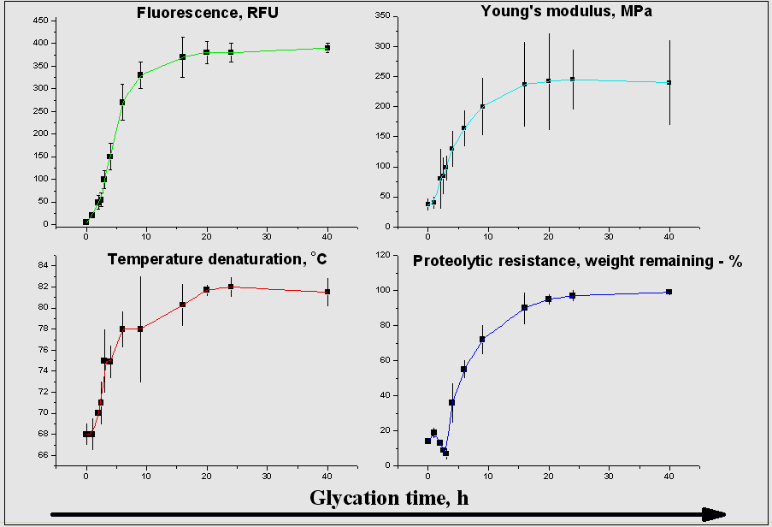

Fig. 1. The general laws of parameters change at cross-linking scleral tissue of GA in the time range of 0 – 50 h (the data is presented as «average»+«standard deviation», n=3). For threose-crosslinking process, we were observed similar graphs, only with characteristic times increased approximately in 7-8 time due to less activity of threose.

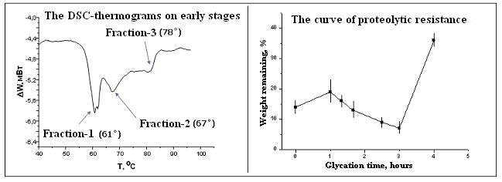

Fig. 2. The observed unique features on the early stages of glycation: typical multi-peak transition on the DSC-thermograms (for both GA and TR) and local minimum of proteolytic resistance (GA only).

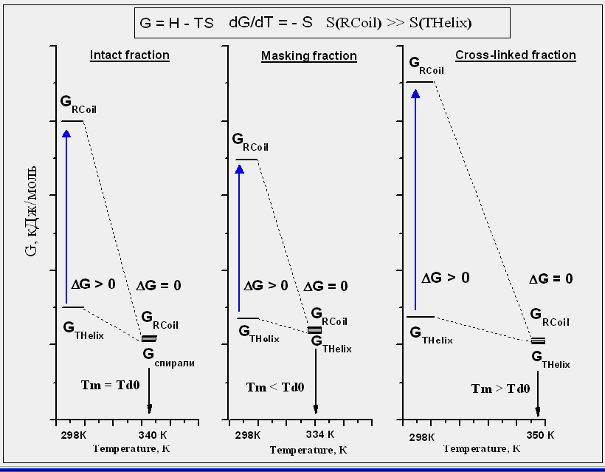

Fig. 3. The thermodynamics of denaturational process in various cases (Тm – melting temperature; Тd0 – denaturation temperature of intact collagen). RCoil, THelix – Random Coil Configuration and Triple Helix Configuration, respectively, of collagen macromolecule.

1 0.1М NaCl, 0.05 M NaH₂PO₄, 0.05 M Na₂HPO₄, 0.02% NaN₃ on 1 liter MilliQ water. pH=7.4.

