EXPERIMENTAL INVESTIGATION AND CALPHAD CALCULATION OF THE Fe–Cr–V SYSTEM

E.G. Kabanova, V.N. Kuznetsov, and .P. Zhmurko

Moscow Lomonosov State University, Moscow, Russian Federation
Kabanova@general.chem.msu.ru

Cr and V belong to most important alloying elements of ferritic steels. However in the Fe–Cr and Fe–V binaries as well as in the ternary intermetalic σ-phase exist which has deteriorating influence on the mechanic properties of materials. So investigation of its conditions of formation and stability regions is of practical importance.
Isothermal section of the Cr–Fe–V ternary at 900ºС was plotted using EPMA, X-ray diffraction and metallography. The samples were prepared using arc-melting. Homogenizing annealing was performed at 900ºС for 750 h.
To perform CALPHAD calculation of phase equilibria in the Cr–Fe–V system thermodynamic models of the fcc, bcc and σ ternary phases were developed. The parameters of phases of the boundary binaries were accepted from the Thermo-Calc databases. Thermodynamic properties of the disordered ternary phases (fcc and bcc) were calculated from the binary ones using Toop extrapolation. For the σ phase three-sublattice model (Cr,V)₄(Fe)₈(Cr,V,Fe)₁₈ was accepted. The parameters for the ternary end-members were determined from phase boundaries. No ternary interactions were accounted for. The results of calculation of phase equilibria in the Cr–Fe–V ternary are in good agreement with experiment (Fig. 1).
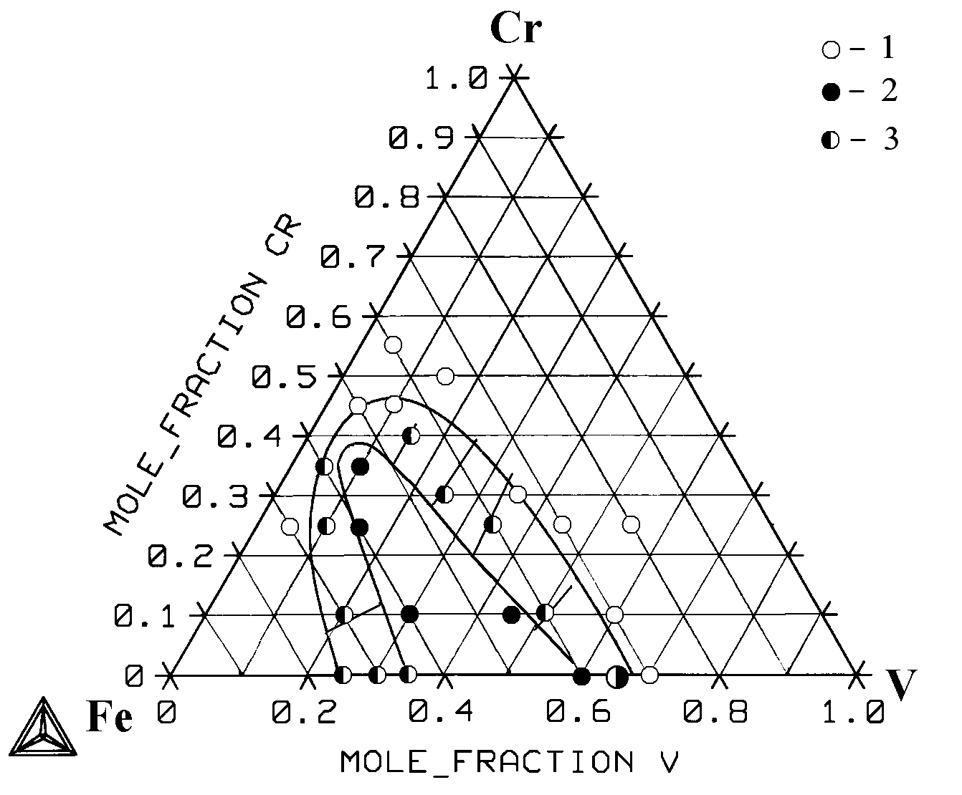
Fig.1. Isothermal section of the Cr–Fe–V ternary at 900ºС. Line – calculation, point – experiment: 1 – bcc, 2 – σ, 3 – bcc + σ.

