Т-Х-Y DIAGRAMS WITH SYNTECTIC-MONOTECTIC TRANSFORMATIONS

V.I. Lutsyk, A.E. Zelenaya

Physical Problems Department, Buryat Scientific Center RAS (Siberian Branch)
8, Sakhyanova str., Ulan-Ude, 670047, Russia; vluts@pres.bscnet.ru

Computer model makes possible to perform the detailed research of phase diagrams and to revealed the phase transformation type change effect in three-phase region. At the simulation of T-x-y diagram with monovariant syntectic equilibrium [1] it was found that the change of syntectic equilibrium (L₁+L₂⇄δ) to monotectic one (L₂⇄L₁+δ or L₁⇄L₂+δ) takes place not only in case of solid solution homogeneity region aperiodicities based on the intermediate compound as was suggested early in [2, с. 324], but in its initial structure as well (fig. a). In last case two ruled surfaces of two-phase reactions L₁→δ and L₂→δ are found. The material balance diagrams allow us to follow the 3-phase reaction change for the given composition. For point G₁(0,45; 0,36; 0,19) the reaction L₁+L₂→δ changes to L₂→L₁+δ, that is the decrease of phase L₁ portion is terminated and its increase begins at temperature 559,73 (fig. b). For composition G₂(0,4; 0,44; 0,16) a transition from reaction L₁+L₂→δ to L₁→L₂+δ begins at temperature 558,67, that is the increment of phase L₂ portion is change (fig. c).
One, two and even three two-phase surfaces could be found in the transformed variant of region L₁+L₂+δ with the intersection of directing lines of ruled surfaces.

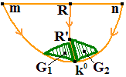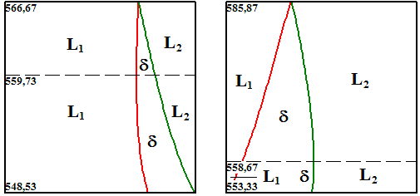
a) b) c)
Fig. Projection of region L₁+L₂+δ with two two-phase surfaces (a), diagrams of material balance for composition G₁ and G₂ (b, c)

REFERENCES

[1] R. Vogel. Die heterogenen Gleichgewichte. Akad. Verlagsgesellschaft, Leipzig, 1959.
[2] K.A. Khaldoyanidi. Phase diagrams of heterogeneous systems with transformation. SB RAS Publ. Comp, Novosibirsk, 2004 (in Russian).

