PHYSICOCHEMICAL BASES OF VEGETABLE OILS TRANSESTERIFICATION IN SUPERCRITICAL METHANOL

R.A. Gazizov, R.A. Usmanov, C.A. Biktach, F.M. Gumerov, F.R. Gabitov

Kazan state technological university, Russia, 420015, Kazan, ul. K. Marksa, 68. rust_vint@hotbox.ru

In the recent years biodiesel fuel has been considered an effective energy carrier prospective in terms of further development of economically feasible methods of obtaining thereof. One of such methods is transesterification of vegetable oils (rapeseed, palm, safflower oils etc.) in supercritical methanol media (T_{cr}=513.0'C; p_{cr}=8.04 MPa).
In this work, periodic process of biodiesel production from rapeseed and palm oil has been realized. Influence of the nature of oil, thermodynamic parametres of the reaction, process duration on product composition and yield has been studied (Fig. 1).
Aiming for bringing the process closer to industrial biodiesel production, laboratory-scale plant (Fig. 2) and pilot-scale plant were built that allow implementation of continuous transesterification reaction process.
A list of oil-containing cultures has been analysed that are potentially suitable and prospective to be used as raw material for biodiesel production.

 | 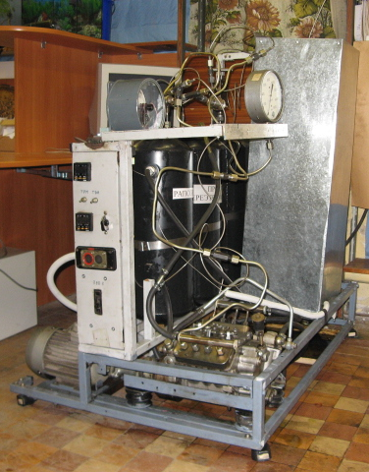
Fig. 1. Yield of fatty acid methyl esters at T=723 K as a function from reaction duration τ.1 - methyl palmitate; 2 - methyl stearate; 3 - methyl oleate; 4 - methyl linolenate; 5 - methyl linoleate; 6 - methyl arachidate; 7 - methyl erucate. | Fig. 2. Laboratory-scale plant implementing continuous transesterification reaction process.

