THERMODYNAMIC OF MOLECULAR INTERACTIONS OF ORGANOPHOSPHORUS DENRIMER NANOLAYERS WITH ORGANIC VAPORS

A.V. Gerasimov¹, M.A. Ziganshin¹, V.V. Gorbatchuk¹, V.I. Kovalenko²

¹A.M. Butlerov Chemical institute, Russia, 420008, Kazan, Kremlevskaya St., 18
² A.E. Arbuzov Institute of Organic and Physical Chemistry, Russia, 420088, Kazan, Arbuzov St., 8.
Alexander.Gerasimov@ksu.ru

In present work the receptor properties of organophosphorus dendrimers of the first (G₁), second (G₂), third (G₃) and ninth (G₉) generation with core >P(S)–, spacer unit p-(–O–C₆H₄–CH=N–N(CH₃)–), branch unit –P(S)< and terminal group p-(–O–C₆H₄–CHO) for vapors of organic compounds and water were studied using quartz crystal microbalance (QCM) sensors. Selectivity and sorption capacity of nanolayers dendrimers films are obtained.
Typical sensor responses ΔF to guest vapor are shown on Figure 1
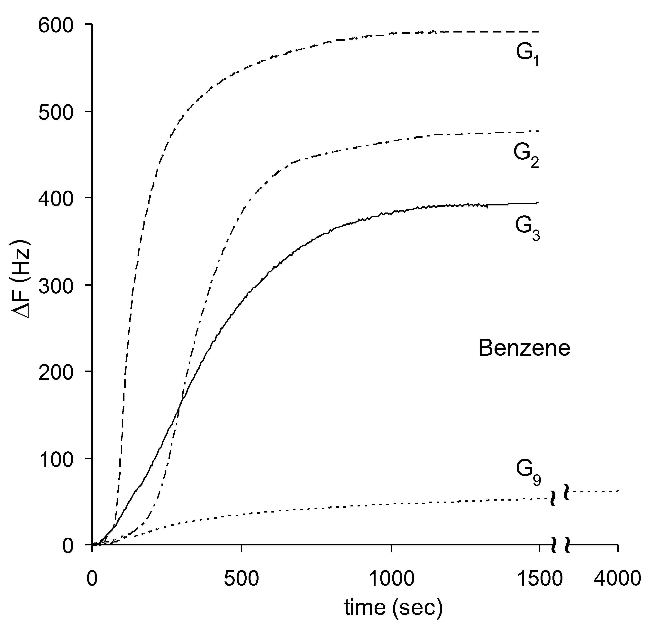
Figure 1. Responses of QCM sensor coated with dendrimers G₁, G₂, G₃ and G₉ to benzene vapors with the relative vapor pressure of P/P₀ = 0.80 at 298 K.

The thermal stability of G₁-G₃ was studied using simultaneous thermogravimetry and differential scanning calorimetry.
The study of guest desorption kinetics using FTIR microspectroscopy showed that at least for some of the studied guests the vapor sorption by dendrimers G₁, G₂ and G₃ in QCM experiment is reversible.
Obtained data indicate a possibility to recognize 20 individual organic vapours using three-sensor array with dendrimers of the first, second and third generation.
This work was supported by the RFBR 08-03-01107 and BRHE (REC-007).

