STRUCTURE OF CRYOLITE MELTS: A COMBINED COMPUTATIONAL AND EXPERIMENTAL STUDY

R.R. Nazmutdinov, T.T. Zinkicheva, D.V. Glukhov, G.A. Tsirlina#,
S. Yu. Vassiliev# and M. Probst&

Kazan State Technological University, K. Marx Str., 68
420015 Kazan, Republic Tatarstan, Russian Federation
#Dept. of Electrochemistry, Moscow State University, Leninskie Gory 1-str.3,
119991, Moscow, Russian Federation
&Institute of Ions Physics and Applied Physiscs, University of Innsbruck, A-6020, Austria
E-mail: nazmutdi@kstu.ru

The structure of cryolite melts is of great interest both from theoretical and practical viewpoint. Despite of numerous attempts to study such melts of different composition, some questions are still poorly understood so far. In the present work cryolite melts were investigated by using Raman spectroscopy, quantum chemical calculations performed at the density functional theory (DFT) level and Car-Parrinello molecular dynamics (CPMD) simulations. Medium effects in the DFT calculations were addressed by means of a continuum model and using large model clusters. Emphasis is put on effects of cation nature (Li⁺, Na⁺ and K⁺) and composition (cryolite ratio) on the melt structure.
We constructed potential energy surfaces describing the formation/dissociation of Al(III) complex species; the fractions and life-times of certain complexes were estimated using the CPMD data. Raman spectra and equilibrium constants were calculated and compared with experimental data. The simplest polymeric forms involving two Al centres linked through F atoms (dimers) were thoroughly investigated. The existence of dimers in the melts was also argued from the fit of experimental Raman spectra. The results of calculations demonstrate a complicated potential energy landscape for different “dimeric” forms; Al₂F₁₀⁴⁻ was found to be the most feasible (see Fig.).
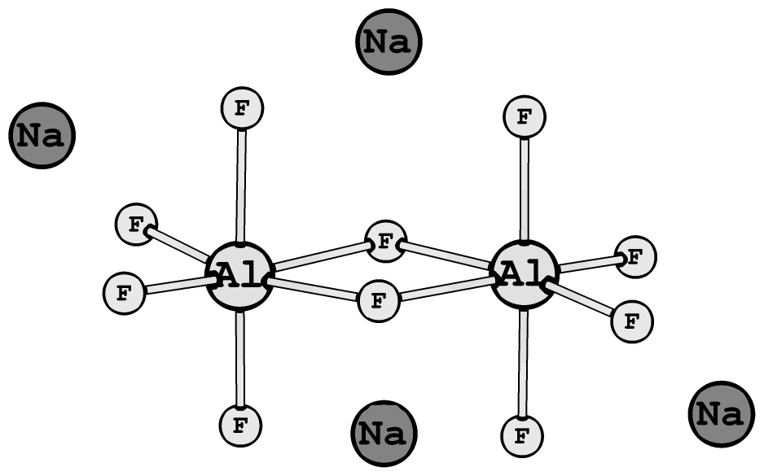
The results of our combined experimental and theoretical study make it possible, to gain a new insight into the complicated structure of cryolite melts. All basic qualitative trends observed in the experimental Raman spectra are confirmed by the results of model calculations.

Fig. Optimized structure of a dimeric complex Al₂F₁₀⁴⁻*4Na.

