Modern Thermodynamics --- On Foundation Stone of Extended Carnot Theorem

Ji-Tao Wang
Fudan University, Shanghai 200433, China

I. Root of puzzlement in thermodynamics --- Carnot Theorem
In thermodynamics forum, everybody knows that Carnot theorem is the foundation stone of thermodynamics (especially of classical thermodynamics) and the starting point of the second law of thermodynamics. Carnot summarized daily macroscopic experiences of human beings in 1824. Carnot theorem could not be deduced from any basic law of other disciplines of science. However, nobody had pointed out that Carnot theorem is also the root of puzzlement in thermodynamics. For instance, Carnot theorem emphasized “reversibility”, but the nature of the second law of thermodynamics is “reversibility” of time for the development of macroscopic systems, i.e. the “arrow of time”. Such a paradox existed and lasted more than 180 years in the past. This was just the root of puzzlement in thermodynamics. Such a status of advocating classicism and excluding modernization is rarely found in other disciplines of science, or we may even say that up to now this is unique.
Now it has been found that the general necessary and sufficient condition for the highest conversion efficiency of energy is “nondissipation” of process or system but not “reversibility” of process or system. This is an extended Carnot theorem. A nondissipative cyclical process (such as a nondissipative Carnot cycle) must be reversible, so the extended Carnot theorem has already included the Carnot theorem, but not vice versa. The extended Carnot theorem is an extended foundation stone of thermodynamics (especially of modern thermodynamics) and a new staring point of the second law in the current 21st century.

II. A Basic and Complete Modern Classification of Thermodynamics
The full import of the concepts originating in Carnot theorem was realized by Clausius through the introduction of the entropy function. In 1865, Clausius said: “In order to express analytically the second fundamental theorem in the simplest manner, let us assume that the changes which the body suffers constitute a cyclical process, whereby the body returns finally to its initial condition. ...”. Thus, the Clausius inequality or the entropy increase principle for isolated (or adiabatic) systems was obtained. However, the “cyclical process” assumption was not included in Clausius inequality or the entropy increase principle at that time. Now the general mathematical expression of the second law of thermodynamics could be written in its entropy production form for any system, i.e. [d_{i}S ≥ 0]. For adding the “cyclical process” assumption into his mathematical expression, the mathematical expression of the second law in classical thermodynamics should clearly be written as [d_{i}S_{p} = d_{i}S ≥ 0].
In the same famous paper, Clausius also said: “The second fundamental theorem, in the form which I have given to it, asserts that all transformations occurring in nature may take place in a certain direction, which I have assumed as positive, by themselves, that is, without compensation; but that in the opposite, and consequently negative direction, they can only take place in such a manner as to be compensated by simultaneous occurring positive transformations.” Clausius’ “compensation” is now called thermodynamic coupling. The system including only “positive” spontaneous process(es) “without compensation” is called uncoupling system, and the system including “negative” nonspontaneous process(es) “compensated by simultaneous occurring positive” spontaneous process(es) is called coupling system.
The first half of this citation confirmed the expression of [d_{i}S_{p} = d_{i}S ≥ 0] for classical thermodynamics. That is, only simple uncoupling systems are considered in classical thermodynamics. Meanwhile, the second half of this citation meant that the mathematical expression of the second law in modern thermodynamics for complex coupling systems should be clearly written as [d_{i}S₁ < 0, d_{i}S₂ > 0 & d_{i}S ≥ 0]. Thermodynamic coupling is the watershed between classical thermodynamics and modern thermodynamics. Here, d_{i}S₁ and d_{i}S₂ (or d_{i}S_{p}) are the entropy production of nonspontaneous process(es) and the entropy production of spontaneous process(es), respectively. d_{i}S is the entropy production of the system, d_{i}S = (d_{i}S₁ + d_{i}S₂). Of course, during Clausius’ time there were no terms of “classical thermodynamics” and “modern thermodynamics”, but there were still differences between uncoupling systems “without compensation” and coupling systems with compensation.
Based only on the mathematical expressions of the second law of thermodynamics mentioned above, the thermodynamics discipline can be presented by a building-image, as shown in Fig. 1. The modernized thermodynamics building grounded on the extended Carnot theorem is more general than the classical one grounded on the Carnot theorem.

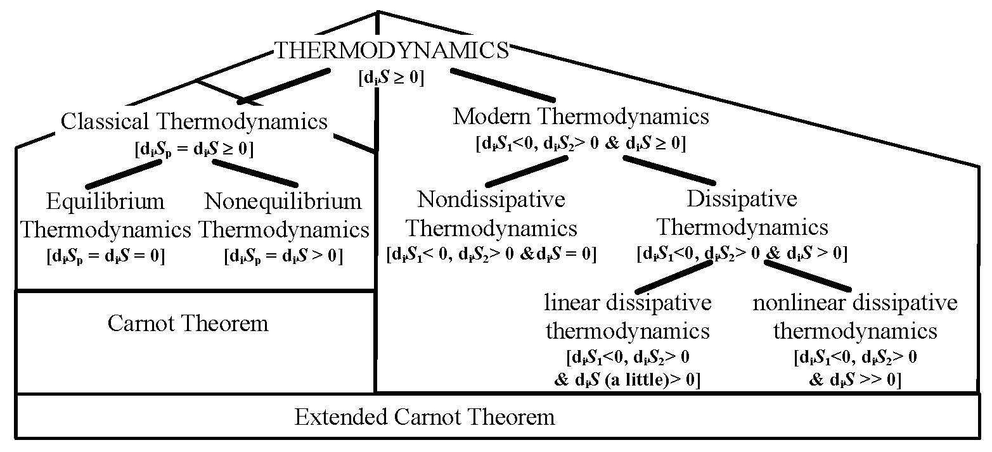
Fig. 1 A basic and complete modern classification of Thermodynamics].

Carnot theorem resulted in the establishment of thermodynamics for reversible processes (i.e. equilibrium thermodynamics) together with nonequilibrium thermodynamics or thermodynamics for irreversible processes in classical thermodynamics. The extended Carnot theorem results in the establishment of a new field of nondissipative thermodynamics (i.e. nondissipative thermodynamics for nondissipative processes) together with dissipative thermodynamics in modern thermodynamics.

III. Spiral Reactions in Dissipative Thermodynamics
Based only on the criterion of thermodynamic coupling, i.e. [d_{i}S₁ < 0, d_{i}S₂ > 0 & d_{i}S ≥ 0], the nature of B-Z reactions or chemical oscillations can simply be explained by a side view of spiral reactions, as shown in Fig. 2. However, chemical oscillations had qualitatively been explained by Prigogine dissipative structures on the basis of his nonlinear positive-feedback kinetic “Brusselator”, i.e. on the basis of an out-of-thermodynamics model. The discovery of spiral reactions can also provide the understanding of Onsager’s single-way cyclical reactions, as shown in Fig. 2 (b), from which Onsager reciprocal relations could not be deduced. As said by Onsager himself, the derivation of his reciprocal relations were on the basis of the introduction of an out-of-thermodynamics “assumption of microscopic reversibility” or assumption of “detailed balancing”. Therefore, Onsager reciprocal relations are not strict thermodynamic quantitative relations. Experimental data also showed their approximation. There is no substantial difference between linear dissipative thermodynamics and nonlinear dissipative thermodynamics.

(a) (b) (c)
Fig. 2 (a) A spiral reaction, (b) A cyclic-like reaction, which is a view of a spiral reaction from up to down along the coordinate of [Time] and (c) A chemical oscillation, which is a view of a spiral reaction from one side along the concentration coordinate of [X] or [Y].

IV. Nonequilibrium Phase Diagrams in Nondissipative Thermodynamics
The activated low-pressure diamond synthesis was first recognized by former Soviet scientists in about 1970, and now the low-pressure diamond synthesis can be used for growing carat-size single-crystal gem-quality diamonds in Carnegie Institution of United States. However, thermodynamic quantitative calculations for nonequilibrium phase diagrams have still been on the basis of nondissipative thermodynamics in modern thermodynamics. There are several decades of papers and 3 monographs have been published by us, and the agreement between theory and experiments are excellent, as shown in Fig. 3, so the author will not repeat to mention more about the new field of nondissipative thermodynamics here.

V. The Least Dissipation (or Entropy Production) Theorem
The least dissipation (or entropy production) theorem is also a generally applicable one. From the mathematical expression of thermodynamic coupling [d_{i}S₁< 0, d_{i}S₂> 0 & d_{i}S ≥ 0], it can be found that if the entropy production of the system agrees with d_{i}S ≥ 0, spontaneous process, i.e. positive entropy production process (d_{i}S₂ > 0), is a kind of potential driving force to drive any possible nonspontaneous process, i.e. negative entropy production process (d_{i}S₁ < 0). For simple uncoupling systems, there is no possibility for nonspontaneous process to take place. The least dissipation theorem was not found just now, because in Onsager’s famous article (1931) “Lord Rayleigh’s ‘principle of the least dissipation of energy’ ” had been mentioned.

Fig. 3 Excellent agreement between theoretical nonequilibrium phase diagram and Marinelli's critical experiments. (a) Nonequilibrium phase diagram calculated at 1173 K and 6.6 kPa. (b) Amplified phase diagram of the ladder-shaped part in (a).

VI. Conclusions
The connotation of the second law of thermodynamics is very abundant. Thermodynamics is a science of development, which is also in its own development. A new book of mine on “Modern Thermodynamics” (Eng. Ed.) will be published soon.

References
- J.-T. Wang: Progress in Natural Sciences, Eng. Edn., 19, 125--135 (2009); doi:10.1016/j.pnsc.2008.07.002.
- R. Clausius, Mechanical Theory of Heat}, (John van Voorst, London, 1867), Ninth memoir
- J.-T. Wang, D. W. Zhang, Z.-J. Liu, Thermodynamic Coupling Model for Low Pressure Diamond Growth from the Vapor Phase (Science Press, Beijing, 1998, reprinted in 2000) 175 pages
- J.-T. Wang, Phase Diagrams of Stationary Nonequilibrium States --- Thermodynamics for Low Pressure Diamond Growth from the Vapor Phase (Science Press, Beijing, 2000) 212 pages
- J.-T. Wang, Nonequilibrium Nondissipative Thermodynamics --- With Application to Low-Pressure Diamond Synthesis (Springer, Heidelberg, 2002)
- J.-T. Wang, Modern Thermodynamics --- and a whole view of thermodynamics (Fudan Univ. Press, Shanghai, 2005) 223 pages

