H-BOND INFLUENCE ON THE VOLUMETRIC PROPERTIES OF p-n-HEXYLOXYBENZOIC ACID - p-n-HEPTYLOXYBENZOIC ACID SYSTEM

S.A. Syrbu¹, L.A. Nosikova², Z.A. Kudryashova²

¹Ivanovo State University, Ermak 39, Ivanovo, 153025 Russia. E-mail: syrbue@yandex.ru
²Lomonosov Moscow Academy of Fine Chemical Technology, Vernadskii pr. 86, Moscow, 117571 Russia

Nanomaterials are forming by nanoparticles self-organization are believed to second generation nanomaterials. One of the self-organization ways are specific inter-molecular interactions. The similar interactions are realized in liquid crystalline carboxylic acids and system on their base.
The density values of p-n-hexyloxybenzoic acid (I), p-n-heptyloxybenzoic acid (II) and 12 mixtures on their base are determined by dilatometric method with error 0.0005 g/sm³.
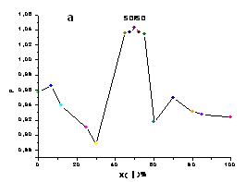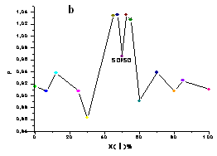
Fig. The density dependence of the system I – II from composition in nematic phase at related temperature -21°С (Т_{rel.}=Т-Т_{Ν→Ν+Ι}) (fig.а) and in isotropic phase at related temperature +8 ⁰С (Т_{rel.}=Т-Т_{Ν+Ι→Ι}) (fig.b).

On the base of polythermal dilatometry is established that «cross» dimers I-II have more close packing in nematic and crystall phases in comparison with I-I or II-II dimers of initial acids (fig. a). The system density decrease at the equimolar correlation of components in isotropic phase (fig. b) can be connected with less close space packing of I-II dimmers at loss of oriental order degree.
The experimental, free and excessive molar volumes, sudden change of molar volumes at phase transitions, molecular packing and thermal expansion coefficients values are calculated by temperature density dependencies.

This study was supported by Russian Education Ministry (project no. RNP 2.1.1./3207).

