VAPORIZATION THERMODYNAMICS OF EUROPIUM DIBROMIDE

M.F. Butmanª, D.N. Sergeevª, V.B. Motalovª, L.S. Kudinª, L. Rycerz^{b},
M. Gaune-Escard^{c}

ª Ivanovo State University of Chemistry and Technology, Engelsa 7, 153000 Ivanovo, Russia butman@isuct.ru
^{b} Chemical Metallurgy Group, Faculty of Chemistry, Wroclaw University of Technology, Wybrzeze Wyspianskiego 27, 50-370 Wroclaw, Poland
^{c} Ecole Polytechnique, Mecanique Energetique, Technopole de Chateau-Gombert, 5 rue Enrico Fermi, 13453 Marseille Cedex 13, France

The vaporization of europium dibromide (99.9%) was studied by high temperature mass spectrometry. Temperature dependences of ion currents are presented in Fig. 1. The partial pressure of molecules EuBr₂ in the saturated vapor was determined to be (1049-1261 K): ln p(EuBr₂)_{Pa} = (-36.224 ± 0.643) ×10³/T + (18.611 ± 0.558). It was found that the fraction of dimers Eu₂Br₄ does not exceed 1 %. In Fig. 2 experimental data on temperature dependence of heat capacity, Cº_{p}, of EuBr₂ obtained by the differential scanning calorimetry in the temperature range of 300-1100 K are shown. For crystal EuBr₂ Cº_{p} = 73.79 + 8 T (± 2.25) J mol⁻¹ K⁻¹. For liquid EuBr₂ Cº_{p} = 105.39 ± 3.32 J mol⁻¹ K⁻¹. The temperature and enthalpy of fusion are 941 K and 22.2 ± 0.4 kJ mol⁻¹ respectively. The thermodynamic characteristics of evaporation/sublimation of EuBr₂ were determined with the use of calculated thermodynamic functions of EuBr₂ in the gaseous («rigid rotator–harmonic oscillator» approach, molecular parameters were taken from [1]) and condensed phases by the IInd and IIIrd laws techniques. The comparative analysis of available literature data on the saturated vapor pressure of EuBr₂ was carried out. The enthalpy of reaction EuBr_{2, cr.} = EuBr₂ was recommended to be _{s}H (298.15 K) = 354  5 kJ mol⁻¹.
 | 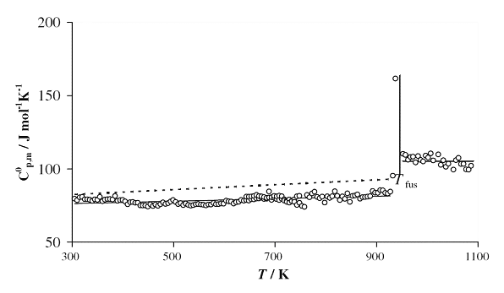
Fig. 1. Temperature dependences of ion currents | Fig. 2 Temperature dependence of molar heat capacity of EuBr₂

REFERENCES
[1] N.I. Giricheva, G.V. Girichev, S.A. Shlykov, O.V. Pelipets. Zhurn. struct. khim. 45 (2004) 50.
This work was granted by RFBR, project No. 09-03-97536.

