THERMODYNAMICS OF SUPRAMolecular INTERACTION OF ZEOLITE-LIKE MATERIAL BASED ON DIPEPTIDE WITH ORGANIC VAPORS

I.G. Efimovaª, M.A. Ziganshinª, V.V. Gorbatchukª, D.V. Soldatov^{b}, S.A. Ziganshina^{c}, A.A. Bukharaev^{c}

ªA.M.Butlerov Chemical Institute, Kazan State University, Kremlevskaya St., 18, Kazan, Russia.
^{b}National Research Council, Ottawa, Canada.
^{c}Zavoisky Physical–Technical Institute, Sibirsky tract, 10/7, Kazan, Russia.
E-mail: iefimova@ksu.ru

Self-assembled peptide nanostructures with hydrophobic porous frameworks designed for a variety of applications have attracted significant research efforts over the last few years.
A direct observation of surface morphology change of thin layer of dipeptides _{L}-alanyl-_{L}-valine and _{L}-valyl-_{L}-alanine after binding the vapors of the neutral organic guest was presented by atomic force microscopy (AFM), Fig.1b. Sorption capacity of the dipeptides was estimate using quartz crystal microbalance (QCM) technique. The strong “size exclusion” effect was observed for binding organic guest with increase their molecular size, Fig.1a.
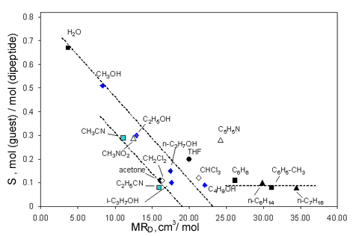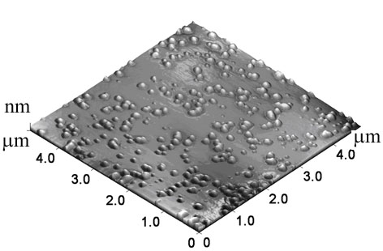
(a) (b)
Figure 1. Correlation between the stoichiometry S and the guest molar refraction MR_{D} for L-alanyl–L-valine (a); AFM image of the _{L}-alanyl-_{L}-valine film after the binding of toluene vapor (b) [1].

The formation of the stable nanosized islands on the dipeptide surface was observed in case binding of toluene and pyridine vapors by L-alanyl–L-valine layer.

This work was supported by programs RFBR № 08-03-01107 and BRHE (REC007)
[1] I.G. Efimova, M.A. Ziganshin, V.V. Gorbatchuk, D.V. Soldatov, S.A. Ziganshina, A.P. Chuklanov, A.A. Bukharaev. Fizikokhimiya Poverkhnosti i Zashchita Materialov. (2009) in press.

