RESEARCH OF INFLUENCE OF THERMAL BACKGROUND OF THE LIQUID PHASE ON CHARACTER OF CRYSTALLIZATION BIPHENYL AND ANTHRACENE

Aleksandrov V.D, Schebetovskаya N.V., Kulik S.V.

Donbas national academy of civil engineering and architecture
Ukraine, 86123, Donetsk region, Makeyevka – 23, Derzhavin's street, 2
cluck@mail.ru

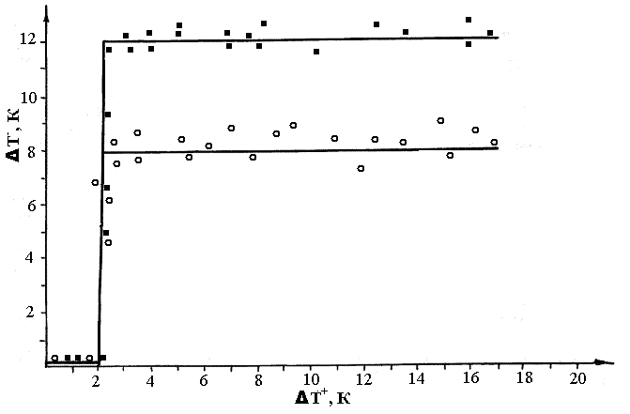
In work are spent for the first time experimental researches of influence of thermal background of a liquid phase on character of crystallization biphenyl (B) and anthracene (A) by a method of the cyclic thermal analysis. Researches spent on samples in weights 0,1 g at speeds of cooling ~ 0,10 К/s. At thermographic these substances spasmodic dependence of overcooling ${ΔТ}^{−}$ on an overheat ${ΔТ}^{+}$ melt concerning fusion temperature (fig. 1) is established.
Transition from quasiequilibrium crystallization to no equilibrium – explosive (with considerable overcooling) for these substances depends on time of preliminary warming up of a liquid phase concerning fusion temperature $Т_{L}$. At weak overheat ${ΔТ}^{+}$ ≈ 2 K to above $Т_{L}$ and further cooling, before crystallization overcooling was close to zero, and at an overheat above 2 K to crystallization occurred to overcooling (for B ${ΔТ}^{−}≈\text{12} К$, for A $8 К$). The further increase in an overheat and a small number thermocycles did not influence overcooling size. It is established also that the isothermal control melts B and A in the field of overcooling leads to spontaneous explosive crystallization.
Fig.1. Dependence of overcooling on an overheat melt for biphenyl () and anthracene ()
Results are treated from the point of view cluster – coagulation models of crystallization taking into account structure of molecules B and A, type of intermolecular interaction in liquid and solid phases.

