THERMODYNAMIC MODELLING OF LIQUID METALLS REFINEMENT

G.G. Mikhailov, L.A. Makrovez, N.M. Tanklevskaya

South Urale State University, Russia
454080, Chelyabinsk, Lenin av. 76 E-mail: nmt_1@mail.ru

The solving of a problem the phase equilibrium analysis in high-temperature systems with liquid metal is closely connected with possibility of manufacturing of ferrous and non-ferrous alloys of high quality. The nature of endogenous nonmetallic phases can be changed under change of concentration of an impurity in the range 10⁻³ – 10⁻⁴ mas.%. Optimal selection of composition of fining and alloying dopes allows us to operate process of formation of nonmetallic phases; and solidification inclusions play a special role in that process.
The method of the thermodynamic analysis of formation of nonmetallic phases and the method of graphic representation of results in a form of special condition diagrams of systems closed to real metallurgical melts have been developed. It has allowed to determine the nature phase equilibrium in liquid metal, to follow dynamics of nonmetallic phases transformation, and to carry out balance calculations of processes of redistribution of components of liquid metal between a metal matrix and the nonmetallic phases, arised during formation of a chemical composition of alloys under cooling and solidification.
The data on thermodynamics of high-temperature reactions of interaction of the components, dissolved of liquid iron, have been summarized and systematized, and the base of the interconsistent data has been made. Mathematical simulation of phase equilibrium, realized in the systems similar to real melts has been performed using that database.
Figure shows the phase equilibria in the Fe-Mg-Al-O system at 1873 K.

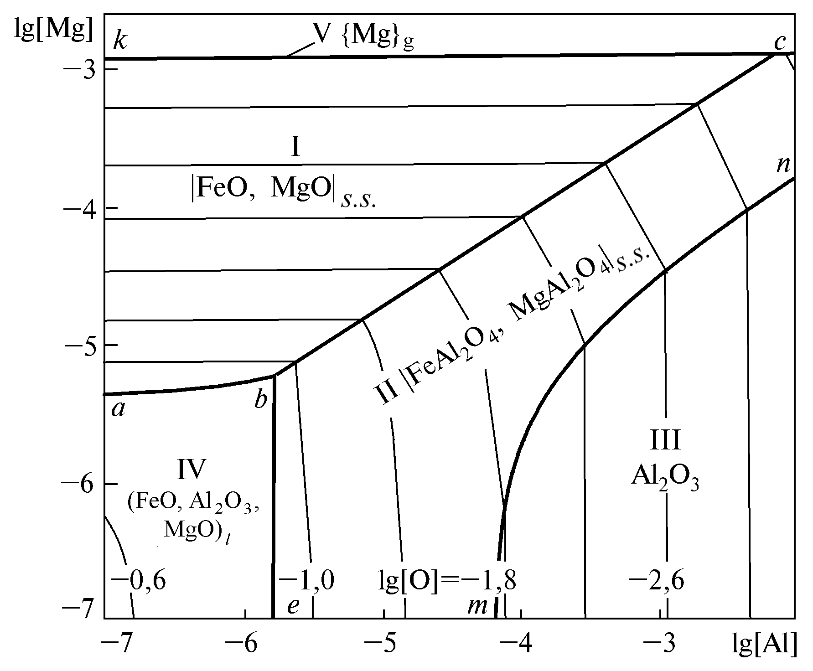
Fig. Phase equilibria in the Fe-Mg-Al-O system

The results of simulation have been compared with the experimental and technological data.

