TERNAPI PROGRAM FOR CALCULATION AND CONSTRUCTION OF PHASE DIAGRAMS OF TERNARY SYSTEMS

A.L. Voskov, D.I. Shishin, V.A. Prostakova, I.A. Uspenskaya, G.F. Voronin

Chemistry Department, Moscow State University, 119991 Moscow Russia
alvoskov@gmail.com

In the Laboratory of Chemical Thermodynamics of MSU a convex hull method have been developed. It allows calculating conditions of phase equilibria unambiguously, without using initial approximations and practically without limitations on the dimension of space of thermodynamic variables [1].
This method has been used in TernAPI program designed for construction of phase diagrams of ternary systems and their sections and projections. The algorithm of program is based on geometrical analysis of convex hull projection of Gibbs energies set of all phases of the system on the Gibbs-Roseboom triangle. Source data are expressions for Gibbs energies and can include NRTL, UNIQUAC, sublattice, polynomial and other models.
The program is written in MATLAB programming language; it is rather universal, has rich abilities of solution visualization and can be effectively used for solving inverse thermodynamic problems due to high speed of work. Examples of diagrams calculated in TernAPI on the base of models proposed in [2] and [3] are shown on the figures.
This work was supported by RFBR, project № 08-03-00506.
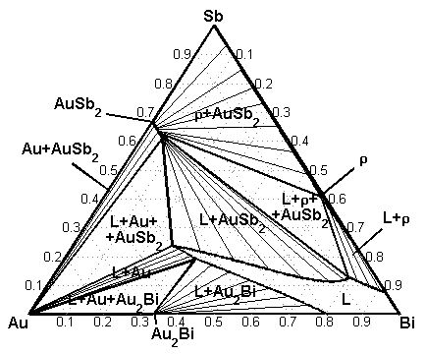  Section of Au-Bi-Sb system phase diagram at the temperature 573 K | 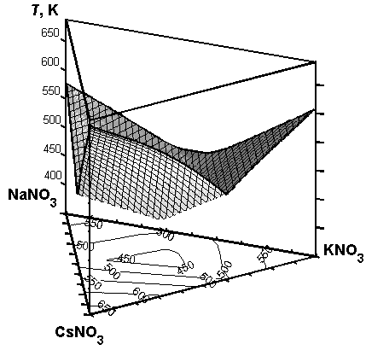  Liquidus surface of CsNO₃-KNO₃-NaNO₃ system
REFERENCES

[1] G.F. Voronin. Russ. J. Phys. Chem. A. 79 (2005) 1890.
[2] J. Wang, F.G. Meng et al. J. Electron. Mater. 36 (2007) 568.
[3] T. Jriri, J. Rogez et al. J. Phase Equil. 20 (1999) 515.

