computer models of eutectic type T-x-y diagrams with inner liquidus fields of low-temperature modifications

V.I. Lutsyk, V.P. Vorob’eva

Physical Problems Department, Buryat Scientific Center, Russian Academy of Sciences
670047, Sakhyanovoy str., 8, Ulan-Ude, Russia vvorobjeva@mail.ru

Transformations of eutectic type T-x-y diagrams with allotropic modifications of components have been considered for the adjusting of real systems sections representations and for analysis of mass balances. The T-x-y diagram with monovariant metatectic transformations at temperatures above binary eutectics (Figure, a) consists of 35 surfaces, bordering 17 phase regions. The number of surfaces (47) and phase regions (20) is equal in two types of diagrams: with binary metatectic & eutectoid (Figure, b) and below the ternary eutectic (Figure, d). The T-x-y diagram with binary eutectoid & peritectoid has more complex construction (59 surfaces, 23 phase regions). Diagrams with polymorphism of two components (A1, B1) (Figure, e) and with three allotropic modifications (B, B1, B2) of the component B (Figure, f) have the equal number of surfaces (90) and phase regions (33).

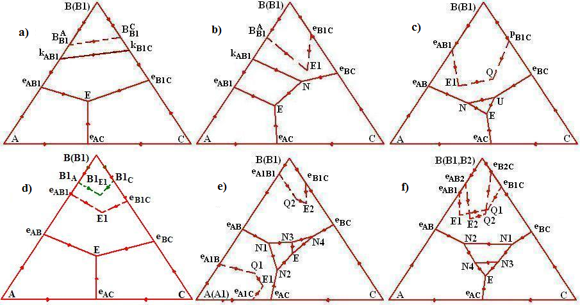
Figure. Liquidus and liquidus type transus: q_{В1} and q^{B}_{B1} (a-d); q_{А1} (N1N3EN2), q_{В1} (N3N4E) and q^{A}_{A1} (A1e_{A1B}Q1E1e_{A1C}), q^{B}_{B1} (B1e_{A1B1}Q2E2e_{B1C}) (e); q_{В1} (N1N3N4N2), q_{В2} (N4N3E) and q^{B}_{B1} (B1e_{AB1}E1Q1e_{B1C}), q^{B1}_{B2} (B2e_{AB2}E2Q2e_{B2C}) (f)

