CARBORANES ON THE BASIS OF BYPYRAMIDAL TRIGONAL DODECAHEDRON: ENUMERATION OF ISOMER SUBSTITUTIONS

V.М. Smolyakov, D.Yu. Nilov, V.V. Grebeshkov

Tver State University, Russia, 170002 Tver, Sadovy per. 35
smolyakov@inbox.ru

Isomer substitutions of bisubstituted carboranes [С₂H_{8-k’-l’}X_{k}Y_{l}B₈H_{8-k-l}X_{k}Y_{l…}] over the nodes of bypiramidal trigonal dodecahedron are considered.. The derivation is based on the Poya theorem. Symmetry formulas Z, generating functions for the number of chiral and achiral isomer substitutions, isomer distributions over the ρ(m) families and depending on the number m of the substitution sites are presented.
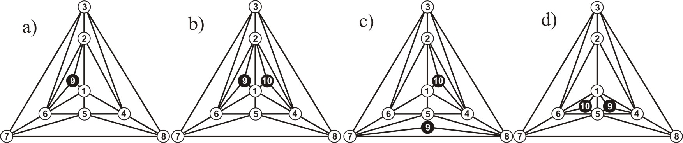
Fig. Graphs of the mono- (а) and bisubstituted carboranes (b, c, d)

The symmetry operations for the polyhedron groups а, b, c, d have the form: C_{1v}: (E, σ_{v}), C_{2v}: (E, C₂, 2σ_{v}), C₂:(E, C₂), σ_{1v}: (E, σ_{v}), whereas the cyclic indices were found:
Z(C_{1v}) = 1/2(f₁⁹ + f₂²f₁⁵) (а), Z(C_{2v}) = 1/4(f₁¹⁰ + f₂⁵ + f₂³f₁⁴ + f₂²f₁⁶), (b),
Z(C₂) = 1/2(f₁¹⁰ + f₂⁵) (c), Z(C_{1v}) = 1/2(f₁¹⁰ + f₂³f₁⁴). (d).
For example, carborane substitutes (b) decompose into ρ(m) = 42: h¹⁰, h⁹x, h⁸x², h⁸xy, h⁷x³, h⁷x²y, h⁷xyz, h⁶x⁴, h⁶x³y, h⁶x²y², h6x²yz, h⁶xyzu, h⁵x⁵, h⁵x⁴y, h⁵x³y², h⁵x³yz, h⁵x²y²z, h⁵x²yzu, h⁵xyzuv, h⁴x⁴y², h⁴x⁴yz, h⁴x³y³, h⁴x³y²z, h⁴x³yzu, h⁴x²y²z², h⁴x²y²zu, h⁴x²yzuv, h⁴xyzuv, h³x³y³z, h³x³y²z², h³x³y²zu, h³x³yzuv, h³x²y²z²u, h³x²y²zuv, h³x²yzuvw, h³xyzuvwf, h²x²y²z²u², h²x²y²z²uv, h²x²y²zuvw, h²x²yzuvwf, h²xyzuvwfq, hxyzuvwfqr, containing for (b) respectively 1, 5, 19, 33, 42, 114, 216, 72, 250, 370, 702, 1356, 82, 366, 706,1368, 2022, 3948, 7740, 882, 1698, 1154, 3330, 6528, 4962, 9726, 19188, 37980, 4416, 6568, 12936, 25560, 19320, 38256, 75960, 151200, 28920, 57312, 113976, 227160, 453600, 907200 isomers, among them respectively 1, 5, 13, 21, 24, 48, 72, 34, 80, 100, 144, 192, 38, 102, 152, 216, 264, 336, 360, 174, 246, 208, 360, 456, 444, 552, 576, 360, 432, 536, 672, 720, 840, 912, 720, 0, 1080, 1224, 1152, 720, 0, 0 isomers are achiral. For 528 X-enantiomers of the polyhedron (c) we have the series: Φ(C₂)= h¹⁰+5h⁹x+25h⁸x²+60h⁷x³+110h⁶x⁴+126h⁵x⁵+110h⁴x⁶+60h³x⁷+25h²x⁸+5h¹x⁹+x¹⁰, and for 576 X-substitutions of the polyhedron (d) the following series are obtained without taking into account the enanthiomerism:
Φ(C_{v}) = h¹⁰+7h⁹x+27h⁸x²+68h⁷x³+116h⁶x⁴+138h⁵x⁵+116h⁴x⁶+68h³x⁷+27h²x⁸+7h¹x⁹+x¹⁰.

