HEAT CAPACITY BOSE-FERMI CONTRASTS OF D₂O AND H₂O LIQUIDS

N.P. Sargaeva^{1,2}, A.N. Baryshev³, L.V. Puchkov⁴, P.M. Sargaev³

¹Saint Petersburg State Polytechnical University, Saint Petersburg, Russia
²Boston University School of Medicine, Boston, Massachusetts, USA
³ Saint Petersburg State Academy of Veterinary Medicine, Saint Petersburg, Russia
⁴ Saint Petersburg State Technological Institute (University), Saint Petersburg, Russia
SargaevPavel <alla-zvy@yandex.ru>

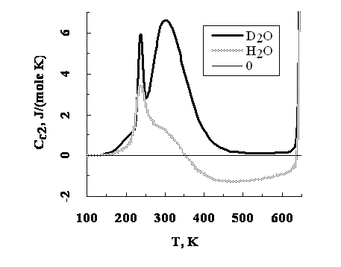
Configurational heat capacity can be represented as to components: C_{c1} and C_{c2} [1]. The first one (the configurational heat capacity of distinguishable particles [2]) is almost identical for H₂O and D₂O and can be determined according to the equation C_{c1} ≅ R⋅G⋅ln(g⋅4^{p}) [2]. Let us call C_{c2} the heat capacity of identical particles. When identical particles interact the oscillating amplitudes may be subtracted (fermions) or summed (bosons). The interaction Fermions might lead to the decline of particle oscillations, and to the decrease of heat capacity of the medium. The interaction Bosons might lead to the oscillation stimulation and to the increase of heat capacity of the medium. At the supercooled liquid and homeostasis temperature, C_{c2} value depends on the Bose-Fermi content (figure 1.). It forms two boson peaks conditioned by the presence of D⁺ cations and proton pairs in the “quantum gas – quantum condensate” reverse transitions described by Einstein [3]. When the temperature increases up to 350 K the proton pairs decay, and the heat capacity C_{c2} of identical particles of H₂O decreases to the negative meanings. At the temperature of the homeostasis frequencies of the configurational proton oscillations fall into the region of the translational frequencies; however, D⁺ cation and proton pair oscillations are in the region of the low frequency threshold of the librational oscillations of water.

LITERATURE

[1] N.P. Sargaeva, A.B. Naymushin, P.M. Sargaev. Izv. RSPU(Herzen Univer.). Natur. and exact sci. 9(48) (2008) 44.
[2] N.P. Sargaeva, P.M. Sargaev. Izv. RSPU(Herzen Univer.). Natur. and exact sci. 7(26) (2007) 112.
[3] A. Einstein. Sitzungsber. preuss. Akad. Wiss., Phys.-math., K1 (1925) 3.

