Three-dimensional numerical modelling of structure formation in the plasma of a dc-driven barrier discharge

Ismail Rafatov
Middle East Technical University, Dumlupinar Blv. 1, 06800 Ankara, Turkey rafatov@metu.edu.tr

We consider a layered system, which consists of a planar electrode, a gas discharge layer, a high-ohmic semiconductor, and another planar electrode. To the outer electrodes a dc voltage is applied. The system is short in the forward direction between the electrodes and has wide lateral dimensions. Experiments showed that such a system is able to create different spatial and spatiotemporal structures (stripes, hexagons, spirals, spots, homogeneous oscillations, etc.). This type of barrier discharge was studied experimentally and theoretically, e.g., in [1-8].
Fig. 1: A cross section of a planar discharge cell: it consist of a metal anode, a gas layer, a high-ohmic cathode, and another metal contact.
We present results of three-dimensional (3D) fluid modelling of temporal and spatial pattern formation in this gas discharge – semiconductor system. Model contains continuity equations for electrons and positive ions with particle densities and ,
where the classical Townsend approximation is used for the ionization rates. Electric field is determined from the solution of the Poisson’s equation,
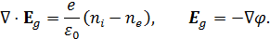
Here, is the electric potential, is the electric field in the gas discharge, is the elementary charge, and is the dielectric constant. The vector fields and are the particle flux densities that

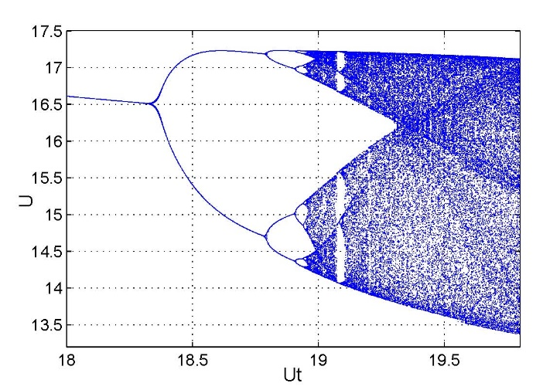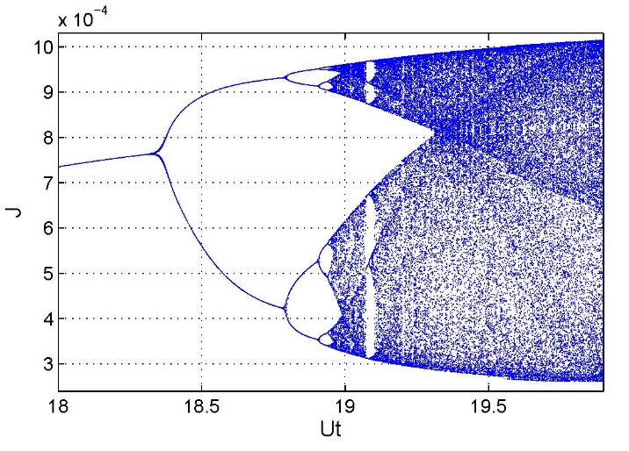

Fig. 2: Bifurcation diagrams, current voltage vs. total applied voltage , obtained for the 1D system. Conditions are the same as in [4]. Parameters are dimensionless.

, .
We neglected diffusion fluxes, so that the particle fluxes are described by drift only with mobilities and . Hence the electric current density in the discharge is
The semiconductor layer of thickness is assumed to have a homogeneous and field-independent conductivity and dielectric constant , electric current and field in the semiconductor satisfy the equations
The ion flux density vanishes on the anode (), so that the boundary condition becomes , where . The boundary condition at the cathode () describes the process of secondary electron emission. Boundary conditions for the electric potential are , , where is the applied voltage.
The time evolution of the surface charge
on the boundary between the plasma and semiconductor () is determined from the equation
.
On the boundaries in the transversal ( and ) directions, we used periodicity conditions [6].

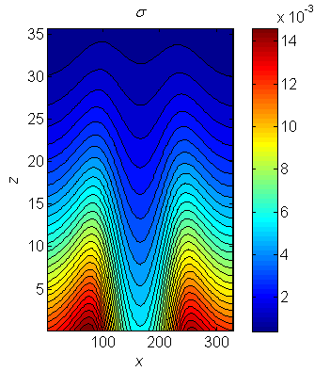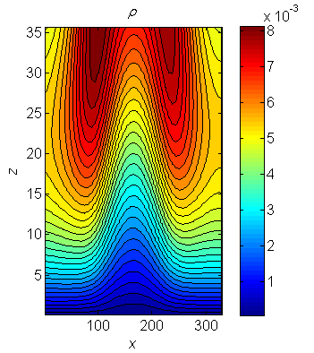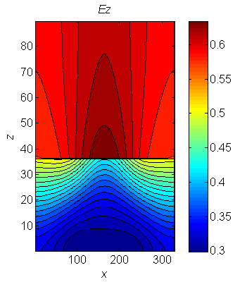
Fig. 3: Temporal snapshot of section (of the 3D computational domain) of electron and ion densities (contour lines) in the discharge region, and of the electric field component (contour lines) in the discharge and semiconductor regions. Conditions are the same as in [6]. Parameters are dimensionless.

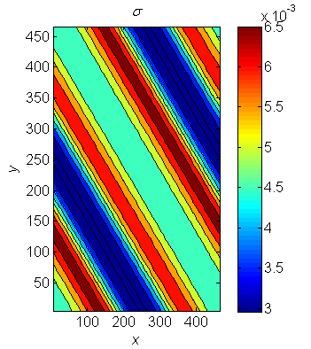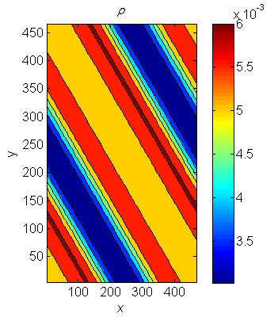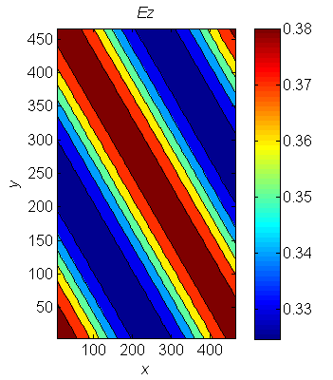
Fig. 4: The same parameters for the same conditions and time step as in Fig. 2 but in the case of section of the 3D computational domain.

Parameter regime corresponds to a transition between Townsend and glow discharge, as in the experiments [1] and in our previous works [4-6]. The discharge is in nitrogen at 40 mbar, in a gap of 1.4 mm. We used the ion mobility cm²/(Vs) and electron mobility cm²/(Vs). The secondary emission coefficient was taken as . The applied voltages are in the range of 513–570 V. The semiconductor layer consists of 1.5 mm of GaAs with dielectric constant and conductivity .
Figure 2, obtained for the condition [1, 4] in the case of 1D model, illustrates a transition of the system from a single period oscillation regime to the irregular chaotic state, through the period-doubling bifurcations cascade.
Figure 3 contains a temporal snapshot of the particle densities and electric filed in the section, and Fig. 4 in the transversal section (”stripe pattern”), for the conditions [1, 6].

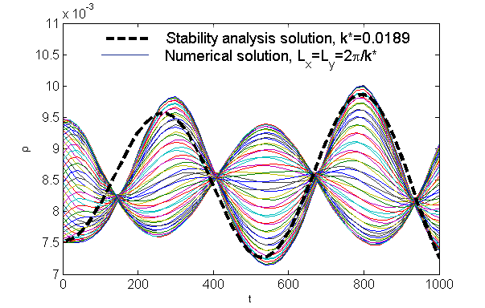
Fig. 5: Comparison of results of the numerical solutions (solid lines) and of the stability analysis (dashed line). Ion density at the computational nodes of the internal border as a function of time for and . Parameters are dimensionless.

Figure 5 show a comparison between the linear stability analysis (about stationary state homogeneous in the transversal direction) and computational results, obtained for the initial conditions of the form
Here is a wave number of the most unstable mode, is the stationary solution, is the eigenfunction for developed in [6]. The stability analysis predicts that and corresponding eigenvalue is [6]. Therefore, the period of the temporal oscillations is predicted as =528, and the characteristic wavelength . Period and growth rate agree sufficiently well.

References

1. C. Strumpel, Y.A. Astrov, H.-G. Purwins, Phys. Rev. E 62 (2000) 4889.
2. Y.A. Astrov, I. M¨uller, E. Ammelt, H.-G. Purwins, Phys. Rev. Lett. 80 (1998) 5341.
3. Y.P. Raizer, E.L. Gurevich, M.S. Mokrov, Tech. Phys. 51 (2006) 185.
4. D.D. Sijacic, U. Ebert, I. Rafatov, Phys. Rev. E 70 (2004) 056220.
5. D.D. Sijacic, U. Ebert, I. Rafatov, Phys. Rev. E 71 (2005) 066402.
6. I. Rafatov, D.D. Sijacic, U. Ebert, Phys. Rev. E 76 (2007) 036206.
7. M.S.Mokrov, Y.P. Raizer, J. Phys. D: Appl. Phys. 44 (2011) 425202.
8. Y.P. Raizer, M.S.Mokrov, Phys. Plasmas 20 (2013) 101604.

