NON-STATIONARY ELECTRON DEGRADATION IN ARGON
V.P. Konovalov, E.E. Son
Moscow Institute of Physics and Technology, Russia
9, Institutsky per., Dolgoprudny, Moscow Region, 141700
konovalov.vp@mipt.ru

The problem of electron degradation spectrum, i.e. electron energy distribution within gaseous medium under external ionization, arises in various applications of low temperature plasma produced by electron beams, impulse lasers, X-rays, etc. An external source generates some primary electrons of high energy in gas, next these primary electron spend their energy in numerous collisions with gas molecules and give rise to secondary electrons as well. The essential feature of such a non-equilibrium plasma is its rather high degree of gas excitation and ionization occurring at low gas temperature, thus there are proper conditions for plasma-chemical reactions to be effected.
In an isotropic weakly ionized gas the Boltzmann kinetic equation for the electron energy distribution function f(ε,t) represents a complex non-stationary integral-differential-difference equation of the following form [1]
,
The electron energy distribution function f(ε,t) depends on electron kinetic energy ε and time t. Here St f are the electron-molecule collision integrals: elastic (m), inelastic excitation (k) and ionization (i); n is the electron concentration, s denotes a primary source of electrons and a stands for the extinction of free electrons because of their possible recombination and attachment. The excitations of rotational (r), vibrational (v), and electronic (j) molecular levels are taken into consideration separately; the sum of ionization integrals includes various ion states. The electron-electron and electron-ion collisions can be neglected in weakly ionized gas.
All the collision integrals can be expressed in terms of the appropriate electron-molecule collision frequencies ν(ε)= Nv(ε)σ(ε), N is the density of particles an electron to impact with; m, v(ε) = (2/m)^{1/2} ε^{1/2} are the electron mass and velocity; σ(ε) is the cross section of the elementary electron impact process

, $ν_{k}\left(ε\right)=Nv\left(ε\right)σ_{k}\left(ε\right)$ ,
,
, , $σ_{i}\left(ε_{p}\right)=\int_{0}^{\left(ε_{p}−ε_{i}\right)/2}{σ_{\text{ii}}\left(ε_{p}{\text{,ε}}_{s}\right){\text{dε}}_{s}}$ ,
ε_{k} , σ_{k} are the threshold and cross-section of k-process of inelastic excitation;
ε_{i} , σ_{i} are the ionization potential and ionization cross-section by electron impact;
σ_{ii}(ε_{p}, ε_{s}) is the differential ionization cross-section; ε_{p}, ε_{s} are the energies of primary and secondary electrons respectively, with the secondary electron being considered that of lesser energy, .
A novel computer code have been developed so that to produce numerical solution of the kinetic equation for electron degradation spectrum in the wide range of electron energies (10⁻¹–10⁴ eV) for any gaseous mixture and for any primary electron source s(ε,t) of arbitrary shape of both energy ε and time t.
Low temperature non-equilibrium plasma produced in argon by external ionization was experimentally examined for its prospective technological applications [2].
The numerical calculations of electron degradation spectrum in argon are being implemented in present research. Rates of multiple electron processes depend on the gas composition and cross sections of electron-molecule collisions. The cross sections for required elementary processes of electron collisions with atoms Ar have been selected with reference to monograph [3]. Six groups of inelastic electronic excitation of argon atom by an electron impact are taken into account separately – (4s), (4p), (3d), (5s), (5p), (Rydberg levels) – with their averaged threshold energies to be 11.8, 13.7, 14.1, 14.3, 14.5, 15.2 eV, respectively. The ionization potential of argon atom is equal to 15.6 eV. The basic calculations of electron degradation in argon have been performed for gas at normal conditions with the pressure 1 atm, concentration of atoms 2.53 10¹⁹ cm⁻³, and gas temperature 290 K.
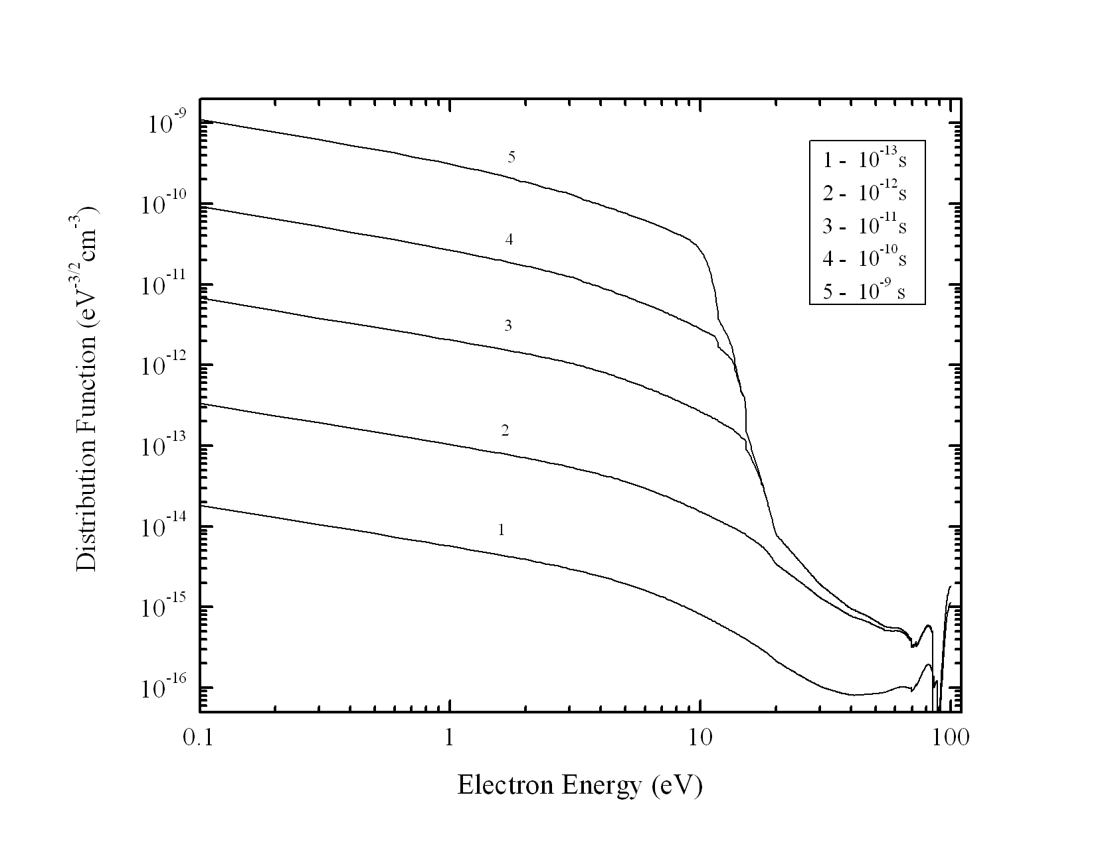
Fig. 1. Temporal evolution of electron degradation spectrum in argon.

Fig. 1 illustrates the temporal evolution of electron degradation spectrum in argon under the steady Gaussian primary electron source with its peak energy 100 eV. The electron degradation spectrum in gas is being established beginning with the high energy range, subsequently the electron distribution settles at the low energy range. In atomic gas, by contrast with molecular gases, there appears a wide under-threshold interval of electron energies where no inelastic electron-atom interaction exists.
The electron distribution function f(ε,t) determines the power p_{k} contributed by electrons into every k-process of excitation or ionization of molecules
,
m is the electron mass; ε_{k} , σ_{k} are the threshold and cross section of k-process.
The general percentage of electron power over electron-atom interactions in argon produced by the calculated electron degradation spectrum is presented in Table 1.

Table 1. Electron-atom interaction yields in argon.

time, s | 10 ⁻¹² | 10 ⁻¹¹ | 10 ⁻¹⁰ | 10 ⁻⁹
ionization, % | 73.3 | 63.9 | 60.9 | 58.8
excitation, % | 26.7 | 36.1 | 38.8 | 39.0
elastic, % | 0.0 | 0.0 | 0.3 | 2.2

The action of an energetic electron on matter is of fundamental importance in radiation physics and chemistry, and the electron energy distribution function (electron degradation spectrum) determines all the rates of elementary electron processes. It is the practice to express the efficiency of gas ionization by the energy price of electron-ion pair (electron-volts per ion pair), W-value, it being constant for external source energies above a few hundred electron-volts. The calculated W-value in argon proves to be rather close to its experimental value 26.4 eV, thus attesting to the computations of electron degradation spectrum.

REFERENCES

1. N.L. Aleksandrov, V.P. Konovalov, E.E. Son. Transfer phenomena for charged particles in weakly ionized gas. In: Encyclopaedia for Low Temperature Plasma. Vol. 1. Moscow, Nauka, 2000 (in Russian).
2. S.H. Seo, J.H. In, H.Y. Chang. J. Appl. Phys. 98 (2005) 083302.
3. G.G. Raju. Gaseous Electronics: Theory and Practice. New York: Taylor & Francis Group, 2006.

