KINETIC ANALYSIS OF VAZO67
MEASURED BY NETZSCH MULTI-MODULE CALORIMETER

Elena Moukhina

NETZSCH Geraetebau, Germany, Wittelsbacherstr.42, D-95100 Selb
elena.moukhina@netzsch.com

Accelerating Rate Calorimeters help industry operate safely and profitably. As highly versatile, miniature chemical reactors, they measure thermal and pressure properties of exothermic chemical reactions. The resulting information helps engineers and scientists identify potential hazards and address key elements of process safety design including emergency relief systems, effluent handling, process optimization, and thermal stability.
The patented VariPhi™ option enables for all Accelerating Rate Calorimeter / Automatic Pressure Tracking Adiabatic Calorimeter systems DSC like performance in the scanning mode: exotherms, endotherms and heat capacity plus pressure data.
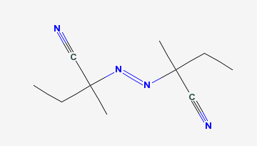
The measurements were done using NETZSCH Multi-Module Calorimeter for VAZO-67 in VaryPhi configuration and constant power input 0.4W. Kinetic analysis was done using NETZSCH Thermokinetics software.

VAZO-67 is the trademark for the substance
2,2′-azobis(2-methyl-butanenitrile): (CH3)2C(CN)N=NC(CH3)2CN
Fig.1 Molecule view for VAZO67

During the measurement the deviation of the heating rate from the constant heating was observed because of the heat evolving. The resulting value of activation energy 131kJ/mol are in agreements with literature data.
Temperature/C

Fig.2 Temperature signal and reating rate during reaction
Fig.3 Kinetic analysis: logarithmus of conversion vs Temperature in Arrhenius scale (-1000/T).points are measured data, line is kinetic simulation.

