The physical-chemical bases of Nickel on kieselguhr catalyst regeneration process using
supercritical carbon dioxide

R.F. Gallymov ², A.A. Sagdeev ¹, F.M. Gumerov ², F.R. Gabitov ², A.M. Nizamov ¹

¹Nizhnekamsk institute of chemical-technology KSTU, Russia, Tatarstan
423570 Nizhnekamsk, Stroiteley str. 47
²Kazan state technological university, Russia, Tatarstan
420015 Kazan, K. Marks str. 68
Rustick_g@rambler.ru

The catalyst of Nikel on kieselguhr is used for the process of isoprene purification from acetylenic compounds. During the process catalytic reactivity reduction is occurred, because activity centers are plugged by coke.
The composition of decontaminant was determined by IR-spectroscopy. Essentially there are products of reaction: isoprene’s oligomers, isoamylenes cis- and trans-, isopropyl group compounds and oxidation products.
Initially regeneration process was implemented using pure supercritical carbon dioxide in the isotherms of Т = 343 К and Т = 423 К at the pressures of 10 MPa, 20 MPa and 30 MPa. Decreasing of decontamination agents of regenerated catalyst was confirmed by IR spectrum.
In subsequent experiments regeneration of catalyst was accomplished using modified (acetone and methanol 3%, 7%-mass fraction of carbon dioxide) supercritical carbon dioxide at the temperature Т = 423 К and pressure Р = 30 МПа.
IR spectrums of deactivated and regenerated catalysts are shown below in fig.1.
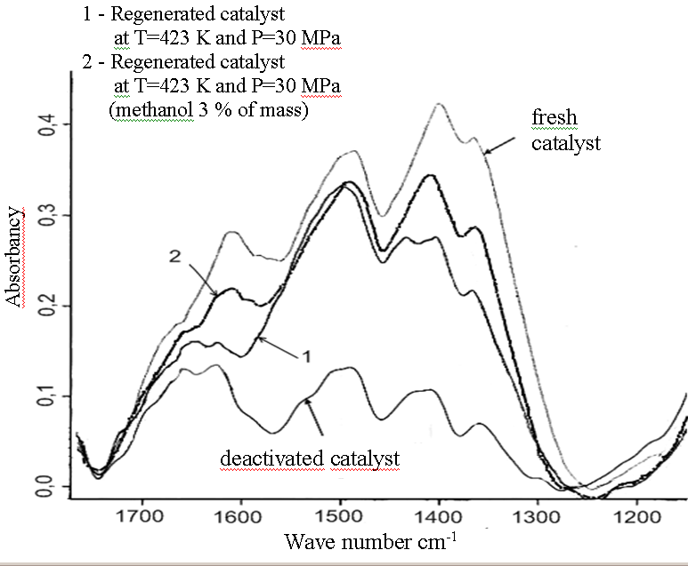
Fig.1 IR spectrums of deactivated and regenerated catalysts
at different process variables.

The conducted analysis of regenerated catalyst samples revealed recovery of catalytic activity up to 92 %. That confirmed a possibility of SCF CO₂ extraction implementation for catalyst regeneration.

