**COMPUTATION OF ENTHALPIES OF THE INDIUM FLUORIDE COMPLEXES FROM TEMPERATURE COEFFICIENTS OF THE DEGREE OF COMPLEXATION**

**Povar Igor, Spinu Oxana**

*Institute of Chemistry, Academy of Sciences of Moldova, 3 Academiei str., Chisinau, MD 2028, Republic of Moldova, e-mail:* [*ipovar@yahoo.ca*](mailto:ipovar@yahoo.ca)

In the previous paper [1] we have derived a series of equations that describe the relationship between the temperature coefficient of the degree of complexation  and the variation of the summary enthalpy  of the reaction of forming complexes with the composition , multiplied by the weighting coefficients . To determine  at temperature *T* it is necessary to know the set of equilibrium constants at this temperature and the  values​​, which are calculated using numerical methods from experimental data ln *α* = *f*(*T*) or ln[*M*] = *f*(*T*), where [*M*] is the equilibrium concentration of metal ion.

The proposed method for determining caloric effects of the reactions of complex formation comprises the following steps. At the beginning, from the equilibrium constants at one temperature the predominance diagrams *fmn* = *f*(- log *CL*) of *N* formed complexes are calculated. Then, for a given value of *CM*, the weight coefficients  are computed for the *N* values of *CL*, for which the individual complexes *MmLn*  are formed in significant amounts. Next, for each of the *N* values ​​of *CL*, not less than five experimental data for different temperatures are measured and using numerical methods is determined. Finally, the values of enthalpy changes  for *N* complexes are determined by solving the system of *N* equations of type [1]:

 (1)

For further elucidation of the possibility to use the proposed method [1] for determining the  values, ​​we will examine a “computing experiment” for the system *In3+ - F-* (*N =* 4).

The quintessence of the "computing experiment" consists of the following stages. From the stability data of formed complexes , known for different temperatures *T*, the dependencies (*T*) are calculated (in our case ∆*T*=10). Subsequently, from the values ​​ , obtained by a suitable numerical method,  is computed. In order to predict the error of the  determination, it is given a certain deviation from the calculated value, comparable to the experimental accuracy for determining the studied quantity. The equilibrium constants of stepwise reactions, which occur in the analyzed system at *T =* 298.15 *K,* are shown in Table 1.

**Table 1.** Composition, stability and variations of the enthalpies for the complex formation reactions in the system *In*3+ - *F-* at *T =* 298 *K*.

|  |  |  |  |
| --- | --- | --- | --- |
| ***Reactions*** | ***logβi*** | ***∆Hexp,*** *kJ/mol* | ***∆Hcalc,*** *kJ/mol* |
| *In3+ + F- = InF2+* | 4.66 | 10.8 | 9.6±0.6 |
| *In3+ + 2F- = InF2+* | 8.13 | 23.3 | 23.3±0.5 |
| *In3+ + 3F- = InF3* | 10.28 | 29.5 | 29.5±0.5 |
| *In3+ +4F- = InF4-* | 11.55 | 38.1 | 38.1±0.5 |

Table 2 illustrates the weight coefficients , calculated by the equation (8) [1], for the various total concentration of fluoride ions in solution ( mol/L). The values ​​of the coefficients of equation (9) for different  values are gathered in Table 2.

**Table 2.** The values of weighting coefficients  for the system mol/L for different values of , *T =* 298 K.

|  |  |  |  |  |
| --- | --- | --- | --- | --- |
|  | *K1 × 105* | *K2 × 105* | *K3 × 105* | *K4 × 105* |
| 0.1 | 9.9 | 2669 | 35550 | 61771 |
| 0.05 | 64 | 8114 | 50679 | 41142 |
| 0.01 | 3135 | 52790 | 40583 | 3480 |
| 0.005 | 14730 | 73981 | 11479 | 348 |

To determine the enthalpies for the reactions of formation of complexes  a system of equations is formed [1]:

 (2)

Indices in brackets refer to the different values. Values of  were obtained by differentiating the equation (10) [1]. Definitely, in Table 3 there are compared the  values measured by the calorimetric method with the  values obtained by the “computing experiment”. The value of deviation in  according to the sign “” characterizes the total error, introduced by the given error  and the error, obtained within the differentiation of . One can see a satisfactory concordance between the compared values of . The difference in the value is explained by the fact that the coefficients  and  are determined within the *CL* range, where the complex  in the whole range of the  measurements is formed in non-significant amounts (Fig. 1).

**Table 3.** The valuesof coefficients of the equation (9) [1] in the system  for different values of the total concentration of fluoride and mol/L; the range of studied temperatures is 278.15 ÷ 318.15 K.

|  |  |  |  |  |  |
| --- | --- | --- | --- | --- | --- |
|  | *A* | *B × 103* | *C × 105* | *D* | *E* |
| 0.1 | -12.163 | 7.9499 | -4.8663 | 2301.9 | -1.2712 |
| 0.05 | -9.4862 | 6.1713 | -3.1288 | 1833.7 | -0.9985 |
| 0.01 | -3.4824 | 2.3556 | 0.2424 | 762.7 | -0.3678 |
| 0.005 | -2802.2 | -180.57 | 103.2 | 53780 | 539.11 |

Therefore, it is necessary to perform experimental measurements  within the *CL* range, where the respective complexes significantly contribute to the total caloric effect of the complex formation reactions. As one can see from Fig. 2, for the same *CL* value, the increase of *CM* leads to decreasing the temperature coefficient . Moreover, it is necessary to take into account that the chosen concentrations *CL*  and *CM* must match the actual range of measured  values​​. We will note that the  determination from the temperature coefficients of the formation function  is accompanied by large errors ( kJ/mol), because this quantity is about one order lower than  (Fig. 2).

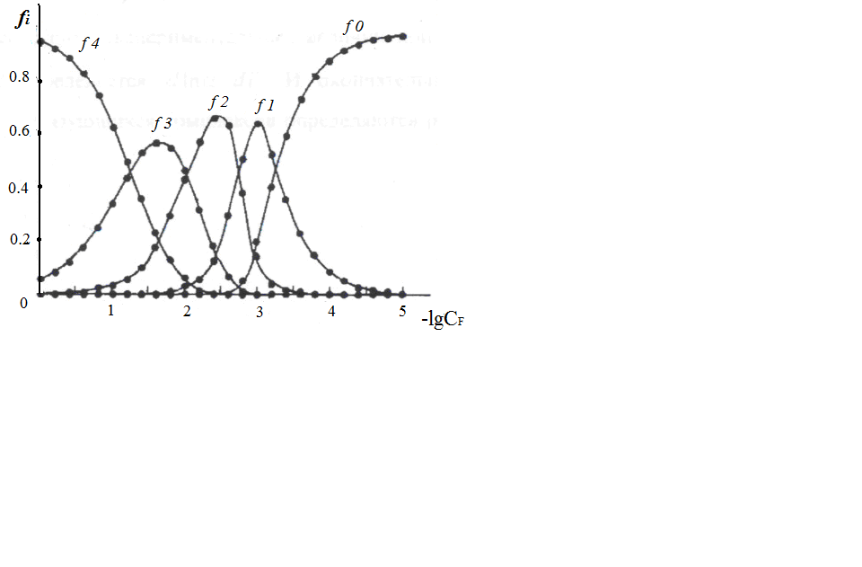

**Fig. 1.** The predominance diagram for the system , *T* = 298.15 K,  mol/L.

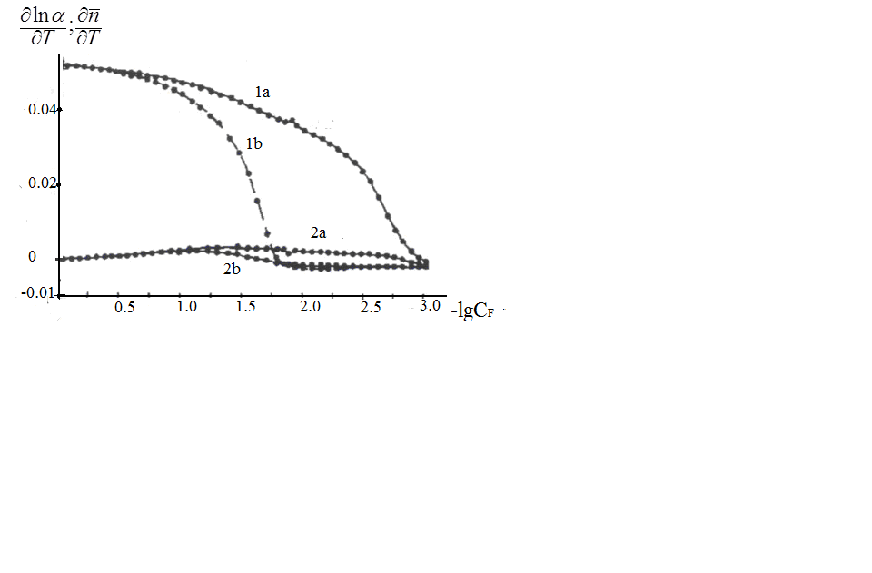

**Fig. 2.** The dependency of temperature coefficients of the complexation degree  (*1*) and  (*2*) on the total concentration of ligand for the system  at *T* = 298.15 K for different values, mol/L: *a –* 0.001; *b* – 0.01.

**References**

1. I. Povar, O. Spinu. *This Conference Proceedings*. Kazan, RCTP-14, 2014.